

Market position statement for information and advice, and advocacy in Newcastle

Contents

3. What is a Market Position Statement?

4. Who is it for?

4. Key Messages

8. Information and advice duties

9. Information and advice - what’s happening in Newcastle

10. Information and advice – what this means for providers

10. Information and advice – what do providers say?

10. What do people who use services, and their carers say about information and
advice?

11. Advocacy duties

12. Future advocacy provision

12. What do people who use services, and their carers say about advocacy?

12. What do advocacy providers say about advocacy?

12. What business development opportunities will this create?

12. How Newcastle Council will help providers be fit for the future
What is a Market Position Statement?

What is driving change?

The Care Act 2014 is driving change. This says the Council must:

- establish and maintain an information and advice service which relates to care and support for all people living in Newcastle.

- establish an information and advice strategy – the formulation of this MPS is the first stage towards this strategy, which we are aiming to be ready for September 2015.

- provide independent advocacy for people in certain circumstances.

Newcastle City Council aspires to be a cooperative council; this means we want to:
- Deliver services in cooperation with communities,
- Enable communities to inform choices about the Council’s priorities,
- Involve communities in deciding how services can be delivered in the future and how to achieve a balance between those services which are available to everyone and those that are for people with an assessed social care need.

Market Position Statements are the first step towards achieving a cooperative approach to the commissioning of services. These documents are designed to help Adult Social Care providers and the people who use Adult Social Care services in Newcastle understand what services are currently on offer in the City, and also what we think Adult Social Care services should look like in the future.

We are producing a range of these documents looking at different client groups and service models in the City.

In developing these documents we have spoken to people that use Social Care services, the people that work in services and the organisations that run them to understand what they think of what’s currently on offer and how they would like to see it change.

We want to use these documents as the start of a conversation with providers, carers and people who use services, about the vision for the future of our Social Care market in Newcastle.

For our information and advice duties, we will need to have an ‘information and advice strategy’ – the conversation that results from this document will go towards shaping this strategy.

In conjunction with this document we have drafted a protocol for advocacy services in Newcastle, which outlines the purpose advocacy, the advocates role and mandatory requirements for providing an advocate.

Who is it for?

What is driving change?

The Care Act 2014 is driving change. This says the Council must:

- establish and maintain an information and advice service which relates to care and support for all people living in Newcastle.

- provide independent advocacy for people in certain circumstances.

Key Statistics

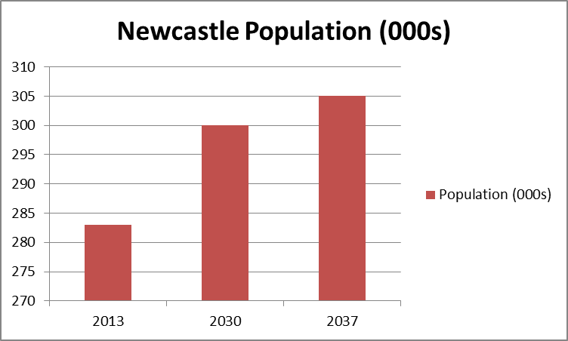

Numbers of older people with long term illness or potential care needs will increase substantially up to 2030. Information and advice to prevent, reduce, and delay the need for long term care needs will be crucial for this group of people.
This document is aimed at:

- Existing and potential providers of information and advice services.

- Service users and carers to understand the direction of travel in Newcastle.

- Health colleagues who will be crucial partners in ensuring the delivery of the co-operative approach which is fundamental to Newcastle City Council’s approach.

- Voluntary and community organisations can learn about future opportunities and what would enable them to build on their knowledge of local needs in order to develop new activities and services.

- Existing and potential providers of advocacy services, to aid them in their future business plans.

Key Messages

Population statistics for Newcastle

Based on the latest ONS population estimates (2013) there are approximately 286,800 people currently living in Newcastle. The population is estimated to grow steadily to around 299,400 by 2030 and to 305,100 by 2037 - a 5.7% growth over the next 17 years to 2030.

Whole population | 2013  000s | 2030  000s | 2037  000s | %+
ONS 2012-based projection | 283 | 300 | 305 | 5.7

- People aged over 85 years and over who cannot manage one activity will increase 67% up to 2030 (2,615 to 3,890) – an extra 1,275 people.
- People aged 85 years and over with a limiting long term illness will increase by 66% up to 2030 (4,048 to 6,141) – an extra 2,093 people.
Ethnicity
Key Statistics

- 81.7% of Newcastle’s population (230,000 people) are White British and a further 3.7% are White Other.

- 14.7% (40,600 people) are non-white (compared with 6.9% in Census 2001).

- We need to ensure our information and advice, and advocacy service is accessible to the whole population.

- 30% of people aged 16-49 have their day to day activities limited a lot by their disability.
- Therefore we need to aim our information and advice messages at this group of people, as well as older people.

Newcastle population by ethnic group. Source: Census 2011.

The 2011 Census suggests that in Newcastle:

- 89.7% of households (where all people aged 16 and over) have English as a main language

- 5.9% of households have no people who have English as their main language, equivalent to 6,927 households

Long-term health problem or disability

Error: Reference source not foundshows the number and proportion of people with a long-term health problem or disability. As would be expected the proportion of people with limited health or disability issues increases with age.
 | Age
Disability | 0 to 15 | 16 to 49 | 50 to 64 | 65 and over | Total
Day-to-day activities limited a lot | 942 | 5,952 | 7,014 | 12,753 | 26,661
Day-to-day activities limited a little | 1,128 | 7,224 | 6,788 | 10,776 | 25,916
Day-to-day activities not limited | 45,904 | 135,179 | 31,327 | 15,190 | 227,600
Total | 47,974 | 148,355 | 45,129 | 38,719 | 280,177

Key Statistics

- Numbers of Adults with learning disabilities is predicted to largely stay the same in 2030.

- However, we have a higher prevalence of people with a learning disability recorded by their GP than other comparable councils.
- This means we have to target information and advice/ advocacy at a higher than average group of people with learning disabilities..

- Numbers of adults with a serious physical disability (aged 18-64) is predicted to remain unchanged between now and 2030.

Learning disability

Error: Reference source not found illustrates the number of adults predicted to have a learning disability.
- In 2014, 4,655 people aged 18-64 years were predicted to have a learning disability.
- The trend is expected to remain similar to 2030 (4,632 people).
- For those aged 65 and over, the numbers are predicted to increase from 852 in 2014 to 942 in 2020 to 1,157 by 2030.

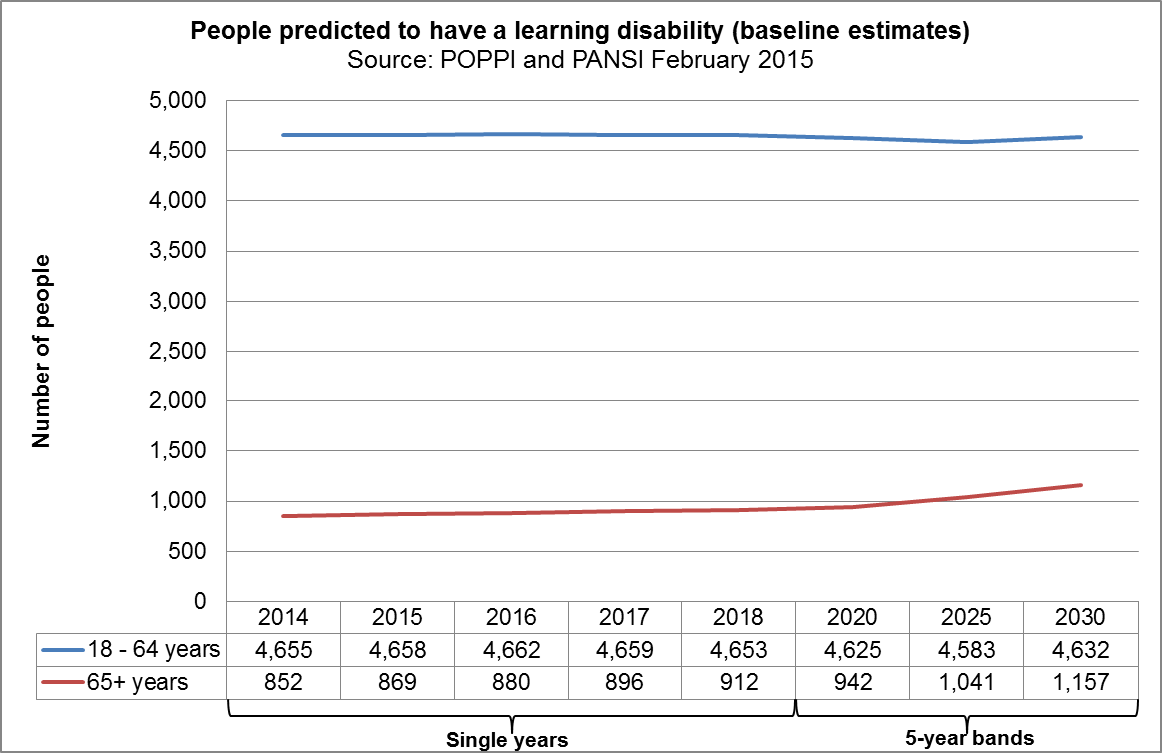

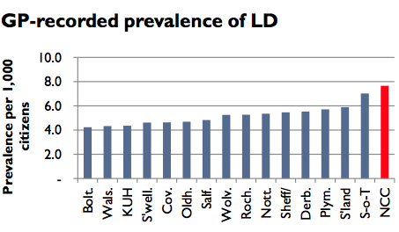

Adults with a physical disability (aged 18-64)
- In 2014, 13,248 people were expected to have a moderate physical disability and 3,708 people a serious disability.
- Over time, predicted trends vary slightly with 13,383 people in 2020 and 13,118 people in 2030 expected to have a moderate disability.
- The number of people with a serious disability is predicted to be 3,797 people in 2020 and 3,710 people in 2030.

Sensory impairment

- 73% predicted increase in adults aged over 65 with a visual impairment by 2030.
- We need to ensure that we address specific information and advice needs of older people.

- 78% predicted increase in Adults with a hearing impairment by 2030.

- 73% predicted increase in Adults with a profound hearing impairment by 2030.

- Numbers of carers aged over 85 years of age will increase by 50% over the next 15 years.

Care Act 2014

England’s care and support system is changing from 1st April 2015. The Care Act will make care and support more consistent across the country. Anyone who receives care and support, or supports someone as a carer, could benefit from the changes as any decisions about care and support will take into consideration people’s mental, physical and emotional wellbeing, with a focus on supporting people to stay healthy and remain independent for longer

The number of people aged 65 and over predicted to have a moderate or severe visual impairment in 2014 was 3,666 (people aged over 75 years account for two thirds of these overall). The numbers are predicted to increase, to almost 4,000 by 2020 and 5,000 by 2030.

The number of adults aged 18 to 64 predicted to have a serious visual impairment is predicted to remain at around 121/ 122 people over the next 15 years to 2030.

In 2014, there were a total of 23,735 people, aged over 18 years predicted to have a moderate or severe hearing impairment. This figure is expected to increase to 25,532 by 2020 and to 30,352 by 2030.

In 2014, there were around 520 people aged 18 and over predicted to have a profound hearing impairment. The trend is predicted to increase to 581 people by 2020 and 708 people by 2030 with just over half of these being 85 and over.

Carers

Census 2011 data suggests almost one in ten (9.2%) of people provide some kind of unpaid care in Newcastle. (approximately 26,000 carers).

Predicted trends produced on the Projecting Older People Population Information System (POPPI) using the Census 2011 figures as the baseline, suggest the number of older people who provide unpaid care will increase by a third over the next 15 years (and those aged 85 and over are predicted to increase by 50%).
Information and Advice Duties

Information and Advice

The key duty in the Care Act 2014 discussed in this document is the duty to ‘establish and maintain an information and advice service’.

The service as a whole must provide information and advice covering:

- The care and support system locally – how the system works, for example - including assessment, and eligibility, complaints, and charges.
- How to access the care and support system locally – including how to make contact, request an assessment, complain / appeal a decision.
- The choice of types of care and support and the choice of care providers available in the area
- How to access independent financial advice on matters relating to care and support.
- How to raise concerns about the safety or wellbeing of an adult with care and support needs (safeguarding issues).

The Care Act places specific new duties on local authorities in relation to the provision of information and advice. The government sees good quality information and advice as being fundamental to enabling adults and their carers to make well-informed choices about care and support. It is also a vital component in promoting wellbeing and preventing or delaying need for care and support.

The information and advice offer must provide information to meet the needs of all the population, including, not just those who are currently in receipt of services, but those who might want to take action to prevent needs developing, or to plan ahead for costs of care and support.

The local authority is not expected to provide all elements of the service, but to ‘understand, co-ordinate and make effective use of other high quality statutory, voluntary and/ or private sector information and advice resources’. The local authority is expected to ‘take a role in joining up information and advice organisations locally so they can work collaboratively.’
The information and advice offer must be accessible, with information and advice open to anyone who would benefit from it. Staff should be appropriately trained to address accessibility issues. Due regard must be given to the needs of those with particular communication needs, including sensory impairment, those who have English as a second language, those who are socially isolated, and those with a disability or mental health problem.

However, the information provided should go beyond care and support, and should include:
- Housing information and advice
- Information about effective treatment and support for health conditions
- Benefits advice
- Availability of carers’ services and benefits
- Information on Lasting Power of Attorney, becoming a deputy, and the Court of Protection
- Raising awareness of the need to plan for future care costs
- Transition from children’s social care

Information and advice - What’s happening in Newcastle

We recognise that Newcastle already has a range of organisations providing a network information and advice to the public on many of these issues. We would like to start a conversation about how adult social care and information and advice providers can work together to ensure there is a comprehensive and integrated information and advice offer. It is unlikely that each individual provider would wish to cover all the above topics, but it is important that the service as a whole can pull together to create the offer, and that providers are able to understand each other’s roles and work together effectively.

Newcastle already has a very effective Advice Compact, which works to ensure consistent communication, standards and advice among agencies, in relation to benefits and debt advice (see appendix). We anticipate that any new arrangement would work alongside and complement the Compact.

In addition, we have broken the rest of the required content down into smaller areas and indicated some of the main providers currently working in those areas:

 | Content | Web resources | Advice providers
Housing | Homelessness  Supported housing  Choices in later life | Tyne and Wear Homes | Housing Advice Centre  Your Homes Newcastle
Equipment | Equipment / adaptations | ADL | Disability North  Caring Hands
Preventative services | Reducing isolation  Transport  Home maintenance | Information Now | Age UK and other agencies
Social care / legal | Social care system  Safeguarding  Eligibility  LPA / deputyship  Signposting to financial advice | NCC website  Information Now  Gov.uk (national) | Age UK  CAB
Health | Staying well  Managing long term conditions  CHC  Services | NTW website  Health Signposts  NHS Choices | Healthwatch  Involve NE
Carers | Welfare rights  Staying well  Available support | Newcastle Carers  Carers UK (national) | Newcastle Carers  PROPS

We support a number of Voluntary and Community Sector organisations to provide services through a variety of funding streams, including the Newcastle Fund. Many of these services support people with lower levels of need and help in preventing needs escalating further, resulting in a reduced demand for statutory services.

What do people who use services, and their carers say about information and advice?

We have spoken to some service user groups, and a wide range of views were expressed. Some of the key points to come out of this work are:

- Website information is increasingly important for some people, but will never be accessed by others – so information and advice needs to be available via other channels.

- Information needs to be consistent across different organisations

- People don’t always know what questions to ask in a particular situation

- Organisations shouldn’t assume that people have any knowledge at all of how the care and support system works.

- People won’t necessarily seek advice proactively – they might only ask for help as they come to a crisis, so the service needs to be set up to give urgent advice.

Information and advice - what this means for providers

We are asking information and advice providers to start to think about how they can work together with Newcastle City Council to start to provide the specific information and advice that the Care Act requires.

Information and advice - what do providers say?

To be added after consultation.

What will services in Newcastle look like?

We would like to suggest some questions as a starting point for the discussion in relation to information and advice

- How can providers work together effectively?

- How can they understand each other’s roles and communicate and signpost effectively?

- What sort of relationship do providers want or need to have with adult social care?

- What information does the Council need to make available?

- How do we make sure people know the information and advice ‘offer’ is there?

- How can we ensure that adults receive the information they need to plan ahead?
Advocacy Duties

Independent Advocacy

The Care Act says we must provide independent advocacy for people who are having difficulty ‘engaging’ in any processes connected with the care act and have no ‘suitable person’ to help them.

We want to know what people who use services, and their carers say about advocacy?

We want to know what the advocacy providers say about advocacy?

“Advocacy is taking action to help people say what they want, secure their rights, represent their interests and obtain services they need. Advocates and advocacy Contractors work in partnership with the people they support to promote social inclusion, equality, and social justice.”

A Code of Practice for Advocates, revised edition 2014

There are statutory obligations placed on local authorities to provide independent advocates in certain circumstances and eligibility to enable an individual to have their voice heard and represented. These are:

- Independent advocacy under the Care Act 2014;
- Independent Mental Capacity Advocates (IMCAs) under the Mental Capacity Act 2005 including the Deprivation of Liberty Safeguards (DoLS);
- Relevant Person’s Representative (RPR) which is covered in the Mental Capacity (Deprivation of Liberty: Appointment of Relevant Person’s Representative) Regulations 2008; and
- Independent Mental Health Advocacy (IMHAs) under the Mental Health Act 1983, as amended 2007.

The government’s aim in reforming the law is to support equality of access, and ensure that all people can be fully involved in the key processes to which their input is essential.

We complete an average of 9,312 Social Care assessments and reviews per year, and there are around 600 Safeguarding Adults cases per year. It is likely that this will increase with the Care Act changes, in particular with the expansion of the Council’s duties around carer’s assessments.

Future Advocacy Provision

Closing date for consultation responses on this document is Friday 15 May 2015.

Please send consultation responses to:
Anna Hayston,
Room 115,
Newcastle City Council,
Civic Centre, Barras Bridge, Newcastle upon Tyne,
NE1 8QH
Phone: 0191 211 5394
E-mail: anna.hayston@newcastle.gov.uk

Key contacts

Commissioning
Write to:
Room 104,
Newcastle City Council,
Civic Centre, Barras Bridge, Newcastle upon Tyne,
NE1 8QH
Phone: 0191 211 5394
E-mail: adult.commissioning@newcastle.gov.uk

Social Care Direct
Phone: 0191 2788377
E-mail: scd@newcastle.gov.uk

At the moment, several organisations provide advocacy support across the City. We do not think this is the best use of resources or the best service we can offer people as it may mean that they have more than one advocate supporting them. People have told us that they want to talk to the same person where possible and that they do not like repeating their story. We also worked with providers, discussing our initial thoughts about what an advocacy service could look like.

We listened to what both people and providers were telling us, shaping the service to reflect their suggestions, and are now in the process of tendering for a new advocacy service across the City which will be delivered either by one provider, or a group of providers working together in partnership.

The new service isn’t the end of the story. We want to keep checking with people to make sure the service is meeting their needs. We also want to make sure that people and providers know how to find the right information and advice to help them make decisions which is why we have linked these needs together.

What business development opportunities will this create?

The inclusion of independent advocacy in the Care Act is a new requirement for local authorities and provides a new opportunity in the market.

What do people who use services, and their carers say about the new advocacy service?
To be added after consultation

What do advocacy providers say about the new advocacy service?
To be added after consultation

How Newcastle Council will help providers be fit for the future

We will do our best to play our part in helping to develop the market by:
To be added after consultation

Appendix

Newcastle Advice Compact

Newcastle’s partnership approach to financial inclusion is based on providing information, advice and support to help people understand and manage their finances. We aim to better understand the pressures people face so that we can develop effective responses to improve residents’ quality of life.

To help us achieve our aims we have focused activity around five objectives that focus on limiting the effects of poverty and supporting those who experience it:

- Maximise income and respond to welfare reform
- Support residents to manage their money and promote access to independent debt and budgeting advice
- Help residents to train, gain and remain in employment
- Promote the expansion of affordable credit options
- Reduce fuel poverty, increase financial resilience and promote access to bank accounts

The role of the Newcastle Advice Compact
To Advice Compact aims to develop agreed, coordinated approaches to the delivery and development of advice services that directly support residents and also provides secondary support to non-specialist agencies.

The Newcastle Advice Compact helped 19,664 people in 2013 – 14 with debt and benefits advice; this included securing £21,902,716 of unclaimed benefits and preventing 4,529 cases of homelessness.

The Advice Compact meets monthly and covers the following areas:

- targeting and take up campaigns
- communications
- performance management
- training
- funding applications
- volunteering
- good practice sharing
- information sharing

Membership
The members are the following agencies that provide not for profit information and advice:

- Active Inclusion Newcastle
- Newcastle Warmzone
- Revenues and Benefits
- Newcastle CAB
- Search Project
- Shelter
- Places for People
- Jobcentre Plus
- Clean Slate CIC
- Newcastle Futures
- Newcastle Law Centre
- Disability North
- Energy Services
- Isos Housing
- Two Castles Housing Association
- Your Homes Newcastle
- Home Group
- Newcastle Welfare Rights Service
- Money Matters
- UK Asset Resolutions
- Grant Thornton
- FINCAN
- Quality of Life Partnership
- Search
- Newcastle University
- Fairer Housing Unit
- Moneywise Credit Union
- Guinness Trust

The work of the Advice Compact is coordinated by Active Inclusion Newcastle (AIN) that facilitates partners to work together at the following levels:

- Primary prevention activities – To facilitate making preventing crises “everybody’s business”. This provides information, briefings, toolkits and consultancy support to partners that are not specialists in housing, welfare rights, debt or employment.
- Secondary prevention activities – At the core of the model are direct specialist information, advice and accommodation services.
- Crisis activities – These services support people when community and preventative support fails to prevent crises. These acute services support people facing destitution.

The Advice Compact provides the direct specialist services that meet the needs described above, this happens in the following context:

Understand local impact – what we need to do for Newcastle residents
- Quarterly reviews for homelessness, financial inclusion, welfare rights, debt, migration and asylum; aligning quantitative and qualitative information; incorporating feedback loops and exception reporting to learn from every crisis that we fail to prevent

Align budget processes to support the most vulnerable
- AIN and the services commissioned through the Crisis Response budget
- Resource allocation – the Newcastle Gateway

Develop citywide consensus and partnership responses – governance / strategy
- Homelessness Prevention Forum – Newcastle’s Homelessness Strategy 2014-19
- Financial Inclusion Group / Newcastle Advice Compact – Newcastle’s Approach to Financial Inclusion
- Cross Council Migration Group

Target support to protect the most vulnerable and to prevent crisis
- Housing, debt and welfare rights advice, floating support and accommodation
- The AIN matrix and spectrum of advice

Provide universal information and advice to prevent people becoming vulnerable
- The AIN “offer” – briefings, trigger point conversations, training and website

Monitor and review the above with partners to create continuous improvement
- Central to this are our databases – evidence bases with common definitions
- Quarterly reviews for homelessness, financial inclusion, welfare rights, debt, migration and asylum; aligning quantitative and qualitative information; incorporating feedback loops and exception reporting to learn from every crisis that we fail to prevent

Consider the individual and structural causes of crisis – identifying the balance of the obstacles to individuals’ inclusion and the structural causes of those obstacles

More information on homelessness can be found financial inclusion here.

Contact officer: Clare Fish Tele: 0191 277 7529 Email: clare.fish@newcastle.gov.uk

