Strengthening the Impact of Public Health Services

Tobacco Control

Our Vision

To support Newcastle’s journey towards becoming a Smoke Free City by reducing smoking prevalence to a rate of 5% or lower by 2030.

A future free from tobacco use will mean our children will not die early and unnecessarily from smoking-related illness. “A Smokefree Future”, Department of Health 2010.

Newcastle’s journey towards becoming a Smokefree city by 2030 creates many challenges for all those working in tobacco control activities. However, with commitment and support, the outcome will prevent many individuals from dying prematurely and ensure no one in Newcastle is harmed from second hand smoke.

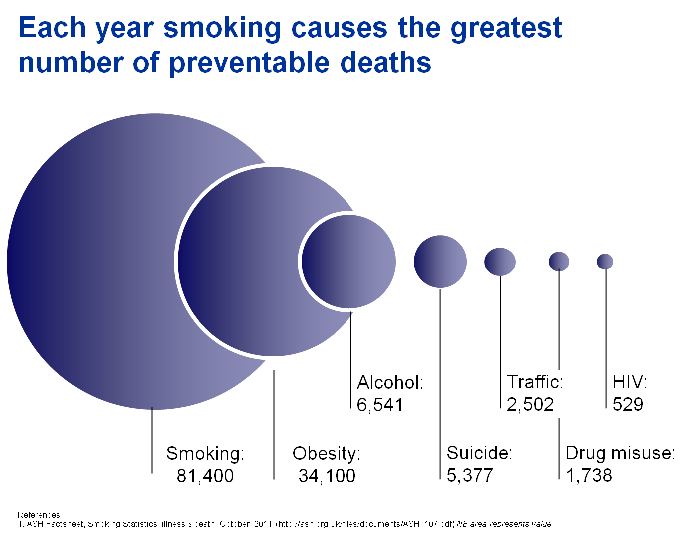

Contents

1. Introduction page 3
Background and context
2. Policy and partnership context page 4
Key public health policy, outcome and partnership drivers at a national and local level and associated risks and opportunities
3. Summary of needs analysis page 6
Population projections, analysis and evidence base
4. Current service provision and financial sustainability page 8
Discussion of the markets currently providing tobacco control initiatives and a review of the current contract mix
5. Where we want to be and commissioning proposals page 8

Commissioning priorities for tobacco control and information about how our plans will be implemented
6. How these plans contribute to the Council’s priorities page 10
How our commissioning plans contribute to the Council’s four priorities
7. High level risks and benefits page 11 Assessing the high level impact of the proposals
8. Cross cutting issues page 11
Proposals which link across our other public health sector briefings

Appendix 1: Key documents
Appendix 2: Prevalence rates

About this document
This briefing is about tobacco control initiatives and forms part of our wider plans for commissioning public health services up to 2016.

Along with our partners, we recognise that tackling inequalities in wellbeing and health and improving wellbeing and health for all involves both improving the conditions in which people are born, grow up, live their lives and grow old, and strengthening the impact of services we provide and commission. With our partners, we are currently inviting comments on Newcastle's first Wellbeing for Life Strategy which lays out the shared commitments for change of all partners. You can find the Wellbeing for Life Strategy at www.letstalknewcastle.co.uk.

In April 2013, Newcastle City Council took over lead responsibility for public health in Newcastle. The council sees this as a once-in-a-generation opportunity to change lives across Newcastle for the better. You can read more about our Vision for Public Health in Newcastle at www.letstalknewcastle.co.uk.

As part of Newcastle City Council's new responsibilities, we have taken over the responsibility for commissioning a range of 'public health' services from the former Newcastle Primary Care NHS Trust. We have grouped these services into a number of topic areas:

- Drugs and alcohol
- Sexual health (a mandatory responsibility)
- Children and young people (incorporating the mandatory responsibility for the National Child Measurement Programme)
- Obesity, nutrition and physical activity
- Wellbeing and health improvement
- NHS health checks (a mandatory responsibility)
- Tobacco
- Fluoridation and oral health

All of these topic areas require a range of policy actions as well as service provision. However, in order to focus in on our new commissioning responsibilities, for each topic area, we have created a document like this one, in which we outline:

- the policy context, including what we are responsible for commissioning;
- our current understanding of needs;
- our understanding of what current services are providing;
- our intentions to change or re-configure what we commission to strengthen their impact.

We are keen to find out from local people and from partners what you think about our intentions. You can comment on our plans at any time by emailing letstalk@newcastle.gov.uk. To find out about other activities that will be taking place, where you can get involved and have your say, visit www.letstalknewcastle.co.uk.

About Newcastle
Newcastle is home to over 279,100 people with a further 90,000 travelling into the city each day to work. It is a modern European city, with a welcoming community, energetic business sector and vibrant culture that creates a great place to live, study, visit and work. It has become a more diverse place to live compared to 10 years ago with a growing black and minority ethnic community. It is also a city where inequalities in health, wealth and quality of life, leave too many people without the ability to participate in society in ways that others take for granted.

- Introduction
Tobacco use is the single greatest cause of preventable deaths in England – killing over 80,000 people per year. This is greater than the combined total of preventable deaths caused by obesity, alcohol, traffic accidents, illegal drugs and HIV infections.

One in every two regular smokers is killed by tobacco, and half of them will die before the age of 70, losing on average 10 years of life. Approximately half of all smokers in England work in routine and manual occupations.

Two-thirds of smokers say they began smoking before age 18, and 9 out of 10 started before the age of 19. Children from homes where smoking is the ‘norm’ are harmed by exposure to second-hand smoke and much more likely to become smokers themselves.

Tobacco use cannot be viewed as just a health issue. It is everyone’s priority because of the toll of death and disease that smoking causes. For tobacco use to be effectively tackled, a range of people need to take action and work together. Tobacco control that is focused, sustained and co-ordinated on a number of fronts, by a wide range of organisations, agencies and individuals, is vital if the significant achievements of recent years in the fight against tobacco use are to be built on.

In England, tobacco control activity is guided by the Department of Health’s six strand approach, based on international evidence that a co-ordinated and multi-faceted response is required to effectively tackle tobacco use.

The essential elements are:

- build Stop Smoking Services and strengthen local action;
- reduce exposure to second-hand smoke;
- support national education and media campaigns;
- reduce tobacco advertising, marketing and promotion;
- tobacco regulation;
- reduce the availability and supply of tobacco products.

Smoking and health inequalities
Smoking rates are the highest amongst the most disadvantaged sections of society and smoking is recognised as a major contributor to health inequalities.

Inequalities arise from both higher levels of uptake as well as lower levels of successful quitting in disadvantaged groups. The Marmot Review, published in 2010 specifically identified investment in evidence-based smoking cessation in disadvantaged groups as a key step to address health inequalities.

Reducing smoking levels can contribute to a number of health inequality measures including:

- improving population health and wellbeing;
- improving life expectancy;
- reducing disparities in life expectancy across populations;
- reducing infant mortality.
2. Policy and partnership context

National context

The government has set three national ambitions to focus tobacco control work. Local authorities are encouraged to develop partnerships in tobacco control where anyone who can make a contribution is encouraged to get involved.

- Reduce smoking prevalence among adults in England: To reduce adult (aged 18 or over) smoking prevalence in England to 18.5% or less by the end of 2015, meaning around 210,000 fewer smokers a year.
- Reduce smoking prevalence among young people in England: To reduce rates of regular smoking among 15 year olds in England to 12% or less by the end of 2015.
- Reduce smoking during pregnancy in England: To reduce rates of smoking throughout pregnancy to 11% or less by the end of 2015 (measured at time of giving birth).
These indicators are included within the Public Health Outcomes Framework 2012.

Support for national media campaigns
National and regional campaigns are well supported in the city with additional activities and communications about the initiatives going out to multiple community venues and in the local press. Two examples of supported national campaigns are set out below.

‘If you smoke, I smoke’ (DoH campaign)
On 31 March 2012, the Department of Health launched a campaign reminding smokers about the dangers of second-hand smoke to their children and families. The adverts dramatised the fact that over 80% of second-hand smoke is invisible and odourless, making it impossible to control.
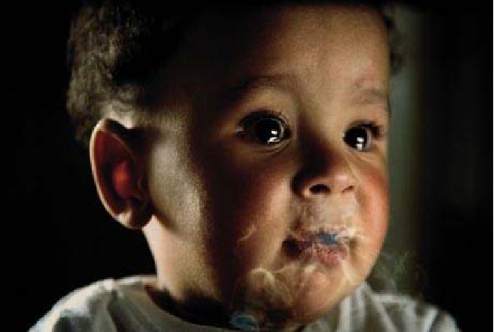

Stoptober
Stoptober encouraged people all across the country to stop smoking together on the 1 October for 28 days (and beyond). Evidence shows that if a smoker can quit for 28 days they are five times more likely to stay smokefree. The impact on local support services will be reported during the first quarter of 2013.



In May 2013, the National Institute for Health and Care Excellence (NICE) will publish their national guidance on Harm Reduction which will focus on the following:

- cutting down prior to quitting;
- smoking less;
- abstaining from smoking temporarily.
These changes might involve substituting the nicotine in tobacco with nicotine from less harmful, nicotine-containing products e.g. Nicotine Replacement Therapy (NRT) or other (licensed) nicotine containing products e.g. e-cigarettes.

e-cigarettes
Current research into e-cigarettes (or “Smokeless non-tobacco cigarettes”) is now underway at the UK Centre for Tobacco Control Studies and Medicines and Healthcare products. Preliminary results have been presented and discussions are taking place locally and regionally on their use and possible impact.
Standardised Tobacco Packaging
New laws in Australia to make cigarettes less attractive to children and young people have been implemented from December 1, 2012. The plain packaging shows the death and disease caused by smoking and is designed to have the lowest appeal. The colourful, glossy packs have gone and in come drab grey-green boxes featuring larger, harder-hitting picture warnings - with pictures of damaged lungs and hearts, gangrenous feet and cancerous tumours.

The law also covers the cigarettes inside - ending the type of colourful, slim fashion cigarettes promoted at young women which have drawn condemnation from North East doctors and MPs.

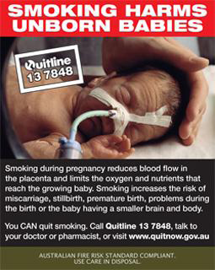

During 2012 a UK-wide consultation took place on the introduction of plain packaging in the UK. Both Newcastle City Council and Newcastle PCT responded to the consultation with their full support.

Local context

Newcastle’s Wellbeing for Life Board (which is the statutory Health and Wellbeing Board from April 2013) is responsible for improving wellbeing and health and, in particular, ensuring the integration of social care, health care and health improvement services in the city. As the future commissioner of tobacco control services, Newcastle City Council will ensure that its Public Health commissioning plans are informed by the Newcastle Future Needs Assessment and fit with the overarching Wellbeing for Life Strategy.

Smoke Free Newcastle (SFN) is a multi-disciplinary and multi-agency group, co-ordinated by Newcastle upon Tyne Hospitals NHS Foundation Trust Community Health Directorate and chaired by Newcastle City Council, which oversees tobacco control issues across the city.

In light of recommendations from the 2011 JSNA on smoking in Newcastle, SFN agreed to develop and implement a pilot programme of activity within the Blakelaw area, providing a range of services and identifying and filling gaps in current provision. People living in those neighbourhoods chose the name for the project, Fresh Air Blakelaw (FAB).

Fresh Air Blakelaw was initiated in 2012 and was called, ‘Smoking Behaviour, Experiences and Perceptions in Blakelaw Neighbourhoods’. The vision of the project is to create a community-driven initiative for health and wellbeing in Blakelaw which contributes to improved wellbeing and reduced health inequalities for its residents. Local champions have been established and work is progressing.

SATOD (Smoking at the time of delivery)
FRESH and the North East Strategic Health Authority worked with midwives and stop smoking services across the North East to roll out a new programme aimed at saving hundreds of lives each year.

Fresh has worked with partners to identify barriers faced by midwives in raising smoking as an issue with pregnant women and is now implementing a new approach called ‘BabyClear’.

The programme has a number of elements:

- all community midwives will be trained in providing an intervention to pregnant women at their first appointment, measuring carbon monoxide (CO) levels;
- a cohort of midwives will be trained to communicate the risks to the unborn baby, with mums-to-be who continue to smoke around the time of their 20-week scan appointment;
- extra training for stop smoking services in working with pregnant women and encouraging mums-to-be to take up free NHS help to quit.

FRESH
Fresh - Smoke Free North East was set up in 2005 as the UK’s first dedicated regional tobacco control office and programme. It is based on an international evidence base and implements a programme to shift the social norms around tobacco use. It has been funded by all 12 PCTs in the North East and hosted by County Durham and Darlington NHS Trust.

The Smoke Free Newcastle group is committed to the development of a co-ordinated strategic approach to reducing smoking prevalence and tobacco use in line with these national aspirations. The achievement of smoking cessation targets remains a key priority for the council through the forthcoming Wellbeing for Life Strategy.

CLeaR - Excellence in local tobacco control
The Smoke Free Newcastle group is currently completing the self assessment exercise, designed for council officers and their partners, to review local action to tackle tobacco. CLeaR is a new approach to improving local tobacco control, specially designed for councils in England as they take on their new responsibilities for public health.

3. Summary of needs analysis

The current snapshot of smoking levels in Newcastle are reflected in the prevalence rates in Appendix 2.

The burden on tobacco in Newcastle
Damage to health caused by smoking does not discriminate between class or wealth. When it comes to the health of the city, smoking is the leading cause of inequalities in Newcastle, accounting for half of the difference in life expectancy between the most and least affluent groups.

The poorer you are the more likely you are to smoke and continue to smoke during pregnancy.

Prevalence of smoking in Newcastle
The Newcastle Future Needs Assessment (NFNA) states that between October 2010 to September 2011, smoking prevalence in Newcastle was reported at 22.9%, a fall of 5.6% on the corresponding period in the previous year. This represents the steepest decline in prevalence of any core city over this 12-month period and Newcastle is no longer the core city with the highest prevalence of adult smoking. It also represents the steepest decline in prevalence amongst North East local authorities over the 12-month period. However, Newcastle’s smoking prevalence remains significantly higher than the England average (20.3%).

Smoking by children and young people
A survey was carried out in 2011 amongst specific year groups in primary and secondary schools in the city. The year groups included:

- year 4 (ages 8-9);
- year 6 (ages 10-11);
- year 8 (ages 12-13);
- year 10 (14-15).

The findings revealed that:
- 1% of primary school pupils and 9% of secondary school pupils reported having smoked in the 7 days prior to the survey;
- smoking prevalence increases with age so that by Year 10, 15% of pupils reported having smoked in the last 7 days prior to the survey, with girls (17%) slightly more likely to smoke than boys (14%);
- 8% of 14 year olds said they were regular smokers. By the age of 15, this rises to 12% of boys and 13% of girls;
- the mean age at which pupils first started to smoke was 12 years.
Smoking is an addiction that takes hold largely in childhood and adolescence, with the vast majority of smokers starting to use tobacco regularly before the age of 18. Given the level of harm caused by tobacco, it is appropriate to use a range of behaviour change interventions.

Smoking cigarettes and other tobacco use i.e. smoking tobacco, shisha or chewing tobacco, are considered normal activity within some groups, and are socially accepted behaviours that lead to addiction.

The power of addiction is grossly underestimated, especially by young people who explore these products. The younger a person starts their tobacco habit the more likely they are to become more heavily addicted, for longer. Young people are three to five times more likely to smoke if they come from a household where either a parent or older sibling smokes.

Smoking by Routine and Manual workers
People in routine and manual occupations are of interest because they account for a greater volume of smokers than any other socio economic group. Research suggests this group may find it harder to stop smoking but they are not hard to reach in terms of wanting to quit. Improved quit rates amongst this group will ultimately de-normalise smoking in communities with the highest smoking prevalence.

Compared to the England average of 30.4%, Newcastle’s rate of smoking in this group is high at 33.6%. This is the second highest rate in the North East and places Newcastle in the middle of the core cities cluster.

Smoking by pregnant women
Smoking during pregnancy increases the risk of complications during pregnancy and labour, including miscarriage. Women who smoke, or who are exposed to second-hand smoke while pregnant are more likely to have a baby of low birth weight than non-smoking mothers. Smoking during pregnancy also increases the risk of Sudden Infant Death (SID).
Reducing smoking during pregnancy is one of the three national aims in the Tobacco Control Plan for England, published in March 2011 which is ‘to reduce rates of smoking throughout pregnancy to 11% or less by the end of 2015 (measured at the time of giving birth).

In 2010/11 Newcastle’s rate of smoking in this group was 18%, compared to the England average of 13.6%. This places Newcastle as the worst performer amongst core cities.

Smoking by people with Long-term Conditions
Smoking contributes to the onset and progression of a range of long-term conditions and whilst smoking cessation is advocated as part of the clinical management of many of these conditions, a significant proportion of individuals with a long-term condition continue to smoke (please see Appendix 3).

The NFNA states that of the patients registered with Newcastle GPs who have been diagnosed with a long term illness, 22.8% were smoking in 201011, a significantly higher proportion than the England average (17.5%).

Economic impact of tobacco
The negative effects of smoking are multiple and reach well beyond the effects of health, some of which are:

Healthcare costs | The costs of treating smoking-related illness amongst smokers and those affected by smoke.
Broader societal costs | Productivity losses – staff absence resulting from smoking related illnesses and premature death.  Environmental costs to clean up smoking related litter.  Fires – in Newcastle smoking related accidents are the main cause of domestic fires.

4. Current service provision and financial sustainability

As reducing smoking prevalence is a key upstream and prevention priority, the complexity of the work in the city cuts across all the six strands of tobacco control work in different proportions.

The funding that supports tobacco control work in Newcastle falls into the following areas:

Theme | No of services | 2013/14 Annual value (£)
Regional work | 1 | 70,072
Specialist services | 1 | 383,500
GP and Pharmacies (including prescribing costs) | Citywide | 151,532
TOTAL |  | £605,104

The Department of Health requires quarterly reports on smoking quit numbers and rates and currently this occurs through the specialist service as it collates all the returns from GP Practices and Pharmacies across the city.

In 2010/11, 3.9% (2,249) adult smokers in Newcastle quit smoking using the specialist service, a lower proportion than in England (4.5%). During the final quarter of 2012/13 a specialised database (QuitManager) is being purchased to enable the local authority and public health to monitor and performance manage the quantitative data set. This will include managing the required reporting to the Department of Health. The development will enable the council to collect more robust data, particularly about routine and manual workers and other targeted groups.

Return on investment
A new interactive tool developed by the National Institute for Health and Care Excellence (NICE) and Brunel University will help local authorities count the cost of tobacco harm in their communities.

Local authority commissioners and Directors of Public Health can use this tool to calculate the cost and savings of putting tobacco control strategies in place over different timescales.

- Where we want to be and commissioning proposals

The future of tobacco control work in Newcastle must encompass multiple elements across all the six strands, including tackling cheap and illicit tobacco. We need all parts of the system working together effectively with improved communication so any individual accessing services can be assured of streamlined provision and support from end to end.

There is a need to decrease prevalence overall, particularly within specific groups and populations e.g. routine and manual, pregnant women, young smokers, BME, unemployed. To achieve this we need to target work specifically at communities and populations with highest prevalence, linking into cluster behaviours. There is also a need to increase the levels of outreach work in these communities, enabling individuals to access services in group settings with colleagues who can also provide support.

We have identified below a number of priority areas in order to meet our vision and outcomes for tobacco control. All commissioned services will be required to report on the relevant public health outcomes and additional performance measures in line with contractual obligations.

There is a need to carry out a full service review in this thematic area in order to maximise the effectiveness of the system, identify any gaps in services provided and increase the number of quitters.

Some key areas of work are as follows:

- Establish on the ground co-ordination in high prevalence areas;

- Make brief interventions a systematic process for frontline staff across organisations;

- Establish training for GPs and Practice staff on ‘Very brief advice’;

- Provide more targeted work in the following populations:
- routine and manual workers
  - under 25 years;
  - over 50 years;
- pregnant women;
- people with mental health problems;
- people with long term conditions;
- BME communities;
- children and young people;

- Work with colleagues in community development roles to become more active in tobacco control activity within their local area;

- Establish a consistent and co-ordinated approach to communications regarding tobacco control, to ensure clear and consistent messages.
The above will be supported through the implementation of ‘QuitManager’ database so the local authority becomes a hub for all tobacco control work.

6. How these plans contribute to the Council’s four priorities
By 2016, we want to achieve the following outcomes for Newcastle: | How our plans contribute to the Council’s priorities:
A Working City:  - Everyone of working age and ability is supported and expected to work.  - Everyone under 25 has the opportunity to be in education, training or employment. Newcastle is known to be business friendly and a good place to invest.  - Newcastle is recognised for the strength of its social and civic enterprises, co-operatives, mutual, voluntary and community sector organisations.  - Everyone can develop their skills to build a career that realises their potential. | A Working City:  - Reducing smoking prevalence should help to reduce ill health, thereby improving quality of life and enabling individuals to live healthier lives, free from disability, and able to participate in the workforce for longer.  .
Decent Neighbourhoods:  - Everyone feels they live in a clean, safe friendly neighbourhood with facilities that meet their needs.  - Everyone is able to have a choice of home that is warm, dry and meets their needs.  - Everyone feels responsible for the area where they live, and for looking after the environment. | Decent Neighbourhoods:  - Reducing smoking prevalence should help to reduce the level of smoking related litter so people can live in cleaner neighbourhoods.
Tackling Inequalities:  - Newcastle’s prosperity is shared more equally.  - No child grows up wanting for love, food, friendship or education.  - Inequalities are reduced.  - Everyone is enabled to lead an independent and fulfilling life.  - Where you are born and where you live does not reduce the quality or length of your life. | Tackling Inequalities:  - We will ensure that staff across organisations are able to deliver brief interventions.  - We will commission more targeted work for populations at higher risk.  - We will establish on the ground coordination in high prevalence areas.
A Fit for Purpose Council:  - The Council is known to be an organisation which enables and empowers others to achieve.  - The Council provides clear and effective leadership for the city.  - The Council is seen as an ambitious and generous partner in the North-East.  - Staff feel motivated, valued and trusted to deliver high quality services.  - The Council demonstrates value for money. | A Fit for Purpose Council:  - We will establish a consistent and co-ordinated approach to communications regarding tobacco control.  - We will work with colleagues in community development roles to become more active in tobacco control activity.

7. High level risks and benefits

An integrated impact assessment will be carried before any change is implemented to ensure that no groups are adversely affected. This will be done in line with the Council's current impact assessment process.

Risks
- Delays in utilising the new database may impact on ability to robustly monitor numbers quitting smoking;
- Critical to reducing smoking prevalence is reliance on identification of key groups and positive work to engage individuals within those groups;
- Number of smoking quitters falls during the transition period.

Benefits
- Increased opportunities to align local partners around a common goal and to add value to the work of the council;
- Re-designed delivery model will provide the catalyst for more focused work to reduce prevalence;
- Opportunities to make services more responsive to local communities i.e. ability to target resources where and how required;
- Opportunities to improve links with other commissioned services, particularly for those suffering from a long term condition;
- Opportunities to develop an integrated model, including children’s and adult social care services, education, etc.;
- Opportunities for integration which ensure compliance with public health legislation such as trading standards and environmental health.

8. Cross cutting issues
Tobacco Control work is multi-faceted and support services do not work in isolation. It is pivotal that services work together and each view themselves as a vital element in the whole system to address the needs of the population.

Appendix 1: Key Documents

Healthy Lives, Healthy People: A Tobacco Control Plan for England. Department of Health March 2011

Excellence in tobacco control: 10 High Impact Changes to achieve tobacco control. Department of Health 2008

The World Health Organisation (WHO) Framework Convention on Tobacco Control. WHO 2004
Marmot (2010) Fair Society, Healthy Lives: Strategic Review of Health Inequalities in England post 2010. UCL Institute of Healthy Equity

The Public Health Outcomes Framework. Department of Health 2012

Local Tobacco Control Profiles for England (2011) www.lho.org.uk
Integrated Household Survey ONS Smoking prevalence by region and local authority April 2010-March 2011. www.lho.org.uk

Know your city: A profile of Newcastle’s people 2012. Newcastle City Council

Royal College of Physicians (March 2010) Passive Smoking in Children
http://ash.org.uk/localtoolkit/docs/cllr-briefings/Children.pdf

NHS Information Centre; Smoking, drinking and drug use among young people in England in 2010. National Centre for Social Research

Kotz D, West R. Explaining the social gradient in smoking cessation: it’s not in the trying, but in the succeeding. Tob Control. Feb 2009;18(1):43-46 www.tobaccocontrol.bmj.com/

McNally L (2009) Quitting in mind. A guide to implementing stop smoking support in Mental Health settings. London Development Centre

Millward D and Karlsen S Tobacco Use among Ethnic Minority populations and cessation intervention. A Race Equality Foundation Briefing Paper May 2011. www.better-health.org.uk

HMRC (2011) Tackling Tobacco Smuggling – building on our success

University of Stirling (2011) Plain tobacco Packaging: A Systematic Review

Royal College of Physicians (2007) Harm Reduction in nicotine addiction: Helping people who can’t quit

Campbell R et all (2008) an informal school based peer-led intervention for smoking prevention in adolescence (ASSIST); A cluster randomised control trial. Lancet 2009 371:1595-1602

Appendix 2: Prevalence rates

Smoking Prevalence for 18 plus years April 2011 – March 2012 |  |  | Change from March 2010 – March 2011
 | % Smokers | Confidence Interval - % Smokers
England | 20% | 19.7% - 20.1% | - 0.7% (statistically significant)
North East | 21.2% | 20.6% - 21.9% | - 1.2% (statistically significant)
Newcastle | 23.6% | 21.2% - 25.9% | - 0.3% (not statistically significant)
Smoking Prevalence in Routine and Manual (R&M) Groups for 18 plus years April 2011 – March 2012
 | % R&M Smokers | Confidence Interval - % R&M Smokers
England | 30.3% | 29.9% - 30.7%
North East | 29.1% | 27.8% - 30.5%
Newcastle | 33.6% | 28.3% - 38.9%

