
Market Position Statement for Adult Learning Disability Services

Contents
Contents
What is a Market Position Statement? 3
Who is it for? 4
Key Messages 5
Current supply 6
What this means for Providers 7
What’s happening in Newcastle? 7
What we do 7
The current framework agreement is coming to an end in March 2017. How we have prepared for the new Framework is detailed later in this document. 8
Finances and funding 9
What People with Learning Disabilities Say 10
Carers and what they say 11
What do providers say? 12
Transforming Care in Newcastle 13
What services in Newcastle will look like 14
What business development opportunities will this create? 15
How Newcastle Council will help providers be fit for the future 15

Drivers for Change 1.

Transforming Care is a change programme for People with Learning Disabilities led jointly by NHS England, the Association of Directors of Adult Social Services, the Care Quality Commission, Local Government Association, Health Education England and the Department of Health.

The Next Steps document (2015) sets out a clear programme of work to improve services for people with learning disabilities and/or autism by driving system-wide change, through focus on the five key areas of:
- empowering individuals
- right care, right place
- workforce
- regulation
- data.

Through Building the right support this partnership has set out a national plan to develop community services and close inpatient facilities for people with a learning disability and/or autism who display behaviour that challenges, including those with a mental health condition.

Newcastle is part of the Cumbria and the North East Transforming Care Partnerships which helped to develop a national service model for commissioners across health and care that defines what good services should look like. More information can be found at: https://www.england.nhs.uk/learningdisabilities/care/

What is a Market Position Statement?
Newcastle City Council aspires to be a cooperative council. This means we want to:
- Deliver services in cooperation with communities,
- Enable communities to inform choices about the Council’s priorities,
- Involve communities in deciding how services can be delivered in the future and how to achieve a balance between those services which are available to everyone and those that are for people with an assessed social care need.

Market Position Statements are the first step towards achieving a cooperative approach to the commissioning of services.

These documents are designed to help Social Care providers and the people who use Social Care services in Newcastle understand what services are currently on offer in the City, and also what we think Social Care service should look like in the future.

We are producing a range of these documents looking at different client groups and service models in the City. In developing these documents we have spoken to people that use Social Care services, the people that work in services and the organisations that run them to understand what they think of what’s currently on offer and how they would like to see it change. We want to use these documents as the start of a conversation with providers, carers and people who use services, about the vision for the future of our Social Care market in Newcastle.

This document should be read in conjunction with the Market Position Statement for Children with Disabilities Services Short Breaks Provision and Enabling Services.

Drivers for Change 2.

The Care Act has had a major impact on the Council in relation to its Social Care responsibilities, extending existing duties and adding new duties.

Some of the major changes being brought about by the act are:
- The Council will have a duty to:
- improve integration with Health partners
- provide preventative services
- provide information and advice signposting
- assess any adult with a need for a care and support service
- facilitate a marketplace that offers a diverse range of high quality and appropriate services

- A national eligibility criteria
- A cap on care costs
- Establishment of universal deferred payment scheme

As the reforms are so far reaching, and changes to the financial position will not be clear for some months, it is difficult to plan ahead at this time.

Who is it for?

This document is aimed at existing and potential providers of learning disabilities services in Newcastle; this can range from providers of floating support and short breaks to independent supported living and specialist residential services.

Providers of current services can learn about our intentions for what services in Newcastle will look like and use this to inform their own planning for the future.

Providers from other areas or people who are interested in starting up social enterprises or a business in this sector can use the document to identify future opportunities in the market.

Key Messages

Population % change 2014 - 2030
 | Newcastle | North East | England
< 18 | 4.71% | 2.23% | 8.77%
18-64 | -0.85% | -4.57% | 3.47%
65 + | 34.14% | 36.38% | 38.97%
Total | 5.31% | 4.49% | 10.84%

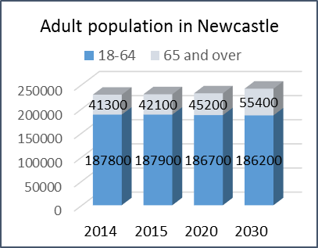

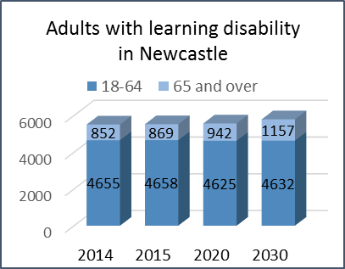

www.poppi.org.uk
www.pansi.org.uk
Crown Copyright 2014

Key Messages

Newcastle City Council’s aim is to buy affordable services which support people with Learning Disabilities to live the life they want, as independently as they can and remain independent for as long as possible. This aim, of course, has to be achieved within restricted means.

In general the demand on Social Care services in Newcastle is increasing at a time when budgets are being cut by central government. This means that we need efficient ways of providing the support people want in order to live the life they want.

The first table on the left shows the overall population in Newcastle is growing, the forecast shows a 5.31% over 2014-2030. This means an increase in the population from 284300 in 2014 to 299400 in 2030.

In terms of adult population, locally the number of people aged 18-64 is predicted to fall by 0.85% from 187800 in 2014 to 186200 by 2030. At the same time there is a predicted 34.15% rise in 65+ age group from 41300 to 55400.

The other graphs on the left and below illustrate there are increasing numbers of adults with learning disabilities. There is an indicator of a rise in numbers of older people with learning disabilities (aged 65 and over), with only slight decrease in 18-64 age group.

In general there are increasing numbers of adults with learning disability who access commissioned services each year. Of these there are increasing numbers who require more complex services. There is also growing pressure on meeting the needs of people with autism and learning disabilities who have dementia.

For people with a learning disability, there are similar trends mirroring the general population. Projections show:
- a very small decrease in 18-64 age group from 4655 in 2014 to 4632 by 2030.
- an increase from 852 to 1157 in the 65 plus age group.
- a similar percentage increase in number of older people with moderate and severe needs .
Key Messages

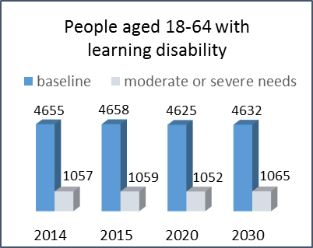

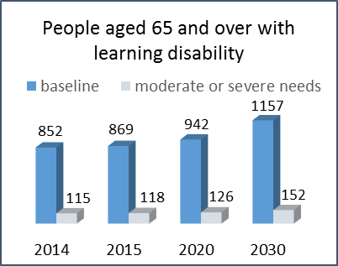

www.poppi.org.uk
www.pansi.org.uk
Crown Copyright 2014

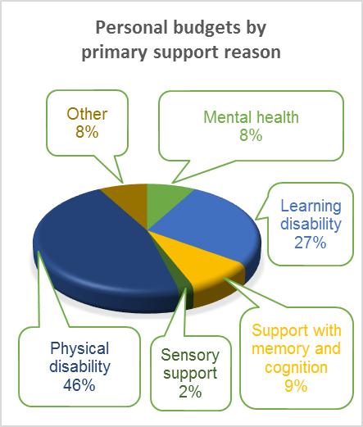
This means that all services will need to increase their capacity to meet the needs of older people with a learning disability who are likely to have increasing health needs.

Current supply

As of 31 March 2016 there were:

- 318 adults with learning disabilities in independent supported living schemes
- 278 adults with learning disabilities who were receiving care at home (including floating support)
- 87 people living in residential placements, 56 of these are living in ‘out of area’ residential placements
- 112 people in supported employment
- 314 people in receipt of direct payments (either standalone or combined with other support), this is 43% of those using self-directed support/ personal budget
- 27% (725) of the personal budgets in Newcastle were held by people with learning disabilities, 91% (657) of those were people aged 18-64 and 9% (68) were people aged 65+

What this means for Providers
Commissioning for outcomes

A key element of the Council’s strategy for future provision of services, this approach puts the service user at the centre of the process, where they specify when and how the service should be delivered.
Outcome focused services are designed to support personalisation. They enable service users to achieve their aspirations, goals and priorities.
This approach shifts the focus of provider’s activities to meeting outcomes by accommodating the choices and preferences of the service user with innovative, flexible and creative support.
Success of the service is measured by whether the service user is satisfied and outcomes are met.
To support working towards outcomes, Newcastle City Council is promoting the use of Individual Service Funds (ISFs).
ISF is an arrangement where in addition to providing direct support under a contract with the local authority, the Service Provider agrees to manage the personal budget on behalf of the Service User, only spending it in the way agreed and described in support plan
It gives people greater choice and control over the design and implementation of the support provided to them, giving them more flexibility to achieve outcomes that matter to them.
ISF’s rely on a relationship with a high level of trust between the Local Authority, the Service Provider, the Service User and their Carer.

The shift in expectation from caring for people to enabling and developing independence means that staff need to have a different attitude and behave in different ways to improve outcomes for people. This has workforce recruitment, training and development implications.
More people with low and moderate needs funding their own care will lead to increase in contracts with individuals rather than the Local Authority. Providers will need to market their services to individuals rather than to commissioners.

There is a focus on people living ordinary lives in ordinary settings and demonstrating the achievement of individual outcomes. This means developing facilitative support which, for example, helps get people involved in their local communities and accessing mainstream leisure, education and employment.

People with complex needs who are currently out of area or in hospital settings are being helped to come home if they want. There is a need for skilled services that provide stable staffing and can support individuals to active positive progression.

To address health inequalities in people with learning disabilities primary healthcare needs to be improved, along with the support for older people.

What’s happening in Newcastle?

What we do

Changes brought about by the Care Act mean that Newcastle City Council funds social care for people that are deemed as eligible for services. We also signpost people to appropriate services no matter what their level of eligibility is.

We support a number of organisations through a variety of funding streams, including the Newcastle Fund and Public Health monies. Many of these services support people that would not be eligible for services, either in the short or long term. This prevents people’s needs escalating which reduces demand on statutory services.

The preferred model of support in Newcastle puts the emphasis on local community provision wherever this is possible. Newcastle City Council commissions the majority of support for people with learning disabilities through framework agreements. These are focussed on independent supported living, day opportunities and to a lesser degree, specialist residential provision.

A number of other services are contracted such as support for direct payments, commissioned at an individual level or funded through grant payments, such as advocacy.

The current framework agreement is coming to an end in March 2017. How we have prepared for the new Framework is detailed later in this document.

Social Finance Project
Newcastle City Council is working with Social Finance to support the development of care services for adults with learning disabilities and/or autism in Newcastle, whilst meeting the financial challenges facing the Council. Social Finance is a social enterprise that works with government, social sector and the financial community to help develop better ways of meeting the needs of the community. Further information on Social Finance can be found at: http://www.socialfinance.org.uk/

In Newcastle, the Social Finance Project Team aim to develop:
- New service models and the enhancement of existing service models through:
- changes to purchasing approaches by identifying the type of support provided and the impact of that support over time, and
- greater use of on-demand models of purchasing and provision, allowing care to be better-aligned to service user needs whilst reducing overall costs. This is likely to include greater use of “Just Checking” and telecare technology to support the monitoring of care.
- A new model of review for individuals and their support needs.
- The infrastructure and new processes required to implement these models.

Newcastle spends around 34% of its gross budget for adult social care supporting people with learning disabilities. The graph illustrated below shows the breakdown for 2015-16 gross expenditure budgets for Adult Social Care
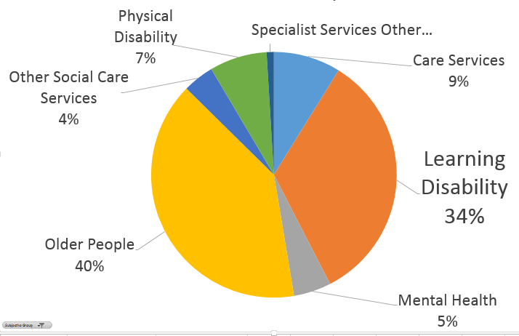

During 2014-15 and in comparison to other areas in the North East and the rest of England Newcastle spends less on average per head of population.

Area | Spend on LD per 10,000 population
Newcastle | £1,192,000
Tyne and Wear | £1,290,000
England | £1,317,000

Finances and funding

In 2014-15 £22.65 million was spent on long term Learning Disability services for people aged 18-64 in Newcastle. The categorisation of services was changed nationally by the Department of Health so there are no comparable figures for previous years.

2014-15 is the first year of data being collected in a new way so it may not be entirely reliable but it shows we spend on average £1.3m less per 10,000 population when compared to the rest of England? The 2015-16 data will be available in November 2016 and will be included in the next refresh of the Market Position Statement.

In 2016-17 we expect to spend £21.4m on Learning Disability services, split as detailed in the graph below:

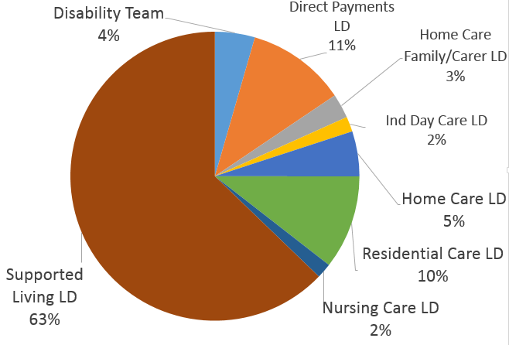
Forecast expenditure 2016/17

What People with Learning Disabilities Say
I want to live on my own, but I’m worried about being left alone at night

From talking to local people we heard the things that are most important to them are: friendships and relationships, transport, jobs, tackling hate crime, transitions and money.
I want to travel independently but I don’t know who to ask for help.

Adults with a learning disability have said:
They want opportunities and support to develop friendships and relationships
They want more social activities especially in the evenings and weekends, and to stay out late.
I want to go on holiday with my friends

I want to go on holiday with my friends
They want to be enabled and feel safe to travel independently on all forms of local transport
They want opportunities to work and jobs that suit them as an individual not as someone with a learning disability. People like having something to do that makes them feel valued – something that makes a contribution to their community
I look forward to having my own place and being independent.
Their main issue is fear of hate crime. They want safe places to go day and night, and for the wider public to know about hate crime and what to do about it.
I look forward to having my own place and being independent
They want to be supported to understand what it means to be an adult, planning their future and supported to discuss this with their parents.
They want to learn money skills to help them be more independent.

Some key messages from carers:

• Parents have an extremely high level of anxiety and fear about the future;

• 85% were either ‘worried’ or ‘very worried’ regarding whether their son/daughter would get the support they need;

• Parents have very little trust in ‘the care system’ to help them plan the future;

• Professionals spend very little time talking with parents about future plans;

• Parents feel it is a ‘battle’ to secure appropriate care and they often lose it;

• There is a lack of clear and accurate information to help with planning.

Foundation for People with Learning Disabilities (2013) Thinking Ahead.

Carers and what they say

Family carers of people with learning disabilities are often unique amongst carers. They often experience a lifetime of caring, as their son, daughter or sibling with learning disabilities lives a longer and more fulfilling life.
During this time they will have developed expertise as they’ve experienced negotiating and sometimes battling their way through the health, education and social care systems.
“The 2014 Newcastle Carers Survey shows that 82% of carers of people with a learning disability who are receiving care and support services from Newcastle City Council are aged 55 years and older (31 out of 38 carers). 24% of the people they care for are aged between 18 and 34 (9 out of 38 people being cared for).”

Eighty seven percent of the carers live with the people they care for.
Results from the 2013 Annual Family Member Carer Questionnaire show that 94.6% of respondents are happy with the care provided, with 93.9% feeling they are kept informed by the provider.

From 163 recorded comments, 147 were positive and 5 were related to service improvements. Eleven of the comments were neutral or negative, with the highest number of these being about waiting for the Provider to respond to an issue they had raised.

Learning disabilities service providers’ reflections:

- We need to know more about the current and future demand for the different types of services and accommodation, including from people who fund their own care.

- The risks of achieving personalisation, a healthy market and quality because of price pressures need to be acknowledged

- We’d like to see clearer benchmarks for quality; a definition of quality in relation to outcomes

- We’d like to know why Newcastle spends more on Learning Disabilities services

- People who use the services having more input into monitoring them.

What do providers say?

We talked with Providers about the Market Position Statement, how we can work together and the learning disability care market at a consultation event in early 2016. A summary of the workshops is below:

Developing the Commissioning Provider relationship:
- What would help? Adopt a range of commissioning methods, more regular engagement, communicating the market drivers.
- Potential barriers: Lack of trust and clear expectations, not sharing information, difficulty in responding to changing commissioning intentions and customer demand, lack of front-line social work presence in discussion forums.
- Overcoming barriers by: Developing partnerships to understand needs, share best practice and training, ensuring service reviews reflect risk and volume and include a range of stakeholder opinion.

Market Structuring:
- What can commissioners do to help? Develop a partnership approach with providers; provide more information about tender limits and opportunities, attract high quality staff to the care market.
- What can providers do to help? Get ready for Individual Service Funds, foster and share innovation and good practice, provide clear information about services on offer.

Transforming Care

Newcastle is part of the Cumbria and the North East Transforming Care Partnerships which helped to develop a national service model for commissioners across health and care that defines what good services should look like.

The nine principles of this national service model are:
- I have a good and meaningful everyday life.
- My care and support is person-centred, planned, proactive and coordinated.
- I have choice and control over how my health and care needs are met.
- My family and paid support and care staff get the help they need to support me to live in the community.
- I have a choice about where I live and who I live with.
- I get good care and support from mainstream health services.
- I can access specialist health and social care support in the community.
- If I need it, I get support to stay out of trouble.
- If I am admitted for assessment and treatment in a hospital setting because my health needs can’t be met in the community, it is high-quality and I don’t stay there longer than I need to.

More information can be found at: https://www.england.nhs.uk/learningdisabilities/care/

Transforming Care in Newcastle

Newcastle City Council wants to change:

- How care management works with people
- How support is designed, commissioned and reviewed for individuals
- How support is commissioned, and monitored with providers

We will achieve some of this change through learning from the Social Finance Project and through our Framework Agreement.

The new Framework moves towards a life-course contract so includes some children’s service. The approach is outcome focussed and the move to Individual Service Funds will help to achieve this for individuals over the lifetime of the Framework.

In preparation for the tender, Newcastle City Council commissioned Inclusion North to engage with Service Users, Families and the Marketplace. This was to help us to shape a Framework which supports the principles of the national service model by ensuring:

- People’s support is person centred and flexible
- Outcome based commissioning is the way of working for everyone
- Support costs are worked out for each person to help get a good life
- Support contracts are flexible and personal
- People with Learning Disabilities, Family members and Service Providers are involved in changes.

Representatives from 23 Service Providers were involved in a series of workshops with Newcastle City Council staff and 26 people who use services from 6 provider organisations and 7 family carers gave their views on the communication and involvement part of the work.

What services in Newcastle will look like
What we will do

We have already opened a first one and are still developing two further Concierge+ schemes for people with learning disabilities (including people who have autism). The Concierge+ schemes aim to improve opportunities for people by giving them more choice and control over where they live and who they live with.

We are also developing four Community Cluster services. The Community Cluster is a brand new service model for Newcastle; these services would centre on a base which is staffed 24 hours a day and from which care and support could be provided to people living nearby in their own homes.

We reviewed the whole range of advocacy services we commission to follow the Care Act 2014 requirements.

We are working with colleagues in the Health Service and Children’s Services to improve support and transitions.
- The main message from the workshops which will help shape the Framework and services was about flexibility for:
  - Individuals - in how people are supported and being able to flex their support.
  - Organisations – in contracts that recognise the flexible support to individuals
  - Social work and commissioning – in how people’s plans and personal outcomes inform their support

- More people will gain and maintain employment (paid and voluntary) through work placements, education and training.
- More people with have their support needs met by accessing social and leisure groups in their local community.
- People will feel safe and part of their local community.
- Providers will work together to develop innovative, evidence based support.
- More people who have complex support needs will be enabled to come home to Newcastle if they want to.
- People will be supported to live where they want, either by themselves or with people they want to live with.
- People will be able to choose from a range of ways to have a break from their family carers.
- People will be able to employ their own Personal Assistants who have the specialist knowledge and skills needed to offer support.
- Providers will work together to create integrated support for people over their life span.
- People will have more choice and control in how they achieve their outcomes through the use of Individual Service Funds.
- Providers will able be more responsive and creative in helping people achieve their outcomes.

What business development opportunities will this create?

Contacts

Commissioning and Procurement
Write to:
Room 104
Newcastle City Council
Civic Centre
Barras Bridge
Newcastle upon Tyne
NE1 8QH
Tel: 0191 2115394
Email: adult.commissioning@newcastle.gov.uk

- Employment, education, voluntary work and training - you may want to provide support that enables people to gain and maintain employment, work placements, education and training, or that enables people to feel a useful and valuable part of their community.
- Advocacy, support planning and brokerage - you may wish to offer services to help people set up and maintain their support plan or provide different types of advocacy support.
- Development and delivery of support - you may want to develop partnerships with other providers to create flexible support options that support people over their lifespan or develop a more specifically skilled workforce to work with people with the most complex behaviours.
- Community activities – you may want to consider providing support that enables people to access leisure facilities, clubs or activities in their local area.

How Newcastle Council will help providers be fit for the future

We will do our best to play our part in helping to develop the market by:
- Maintaining the good relationships that have been developed within the Learning Disabilities Provider Forum
- Developing the Forum to focus more on hot topics in the market
- Hosting events and facilitating dialogue to promote partnerships approaches to shared issues
- Continuing to listen to our Service Users, their Carers/Families and Service Providers.
- Further developing the service review (monitoring) system and go to tender for a new Provider Framework in the summer 2016

Let’s Talk Day, Newcastle, October 2012.
http://www.carers.org/

