What do you think about how the council spends money?

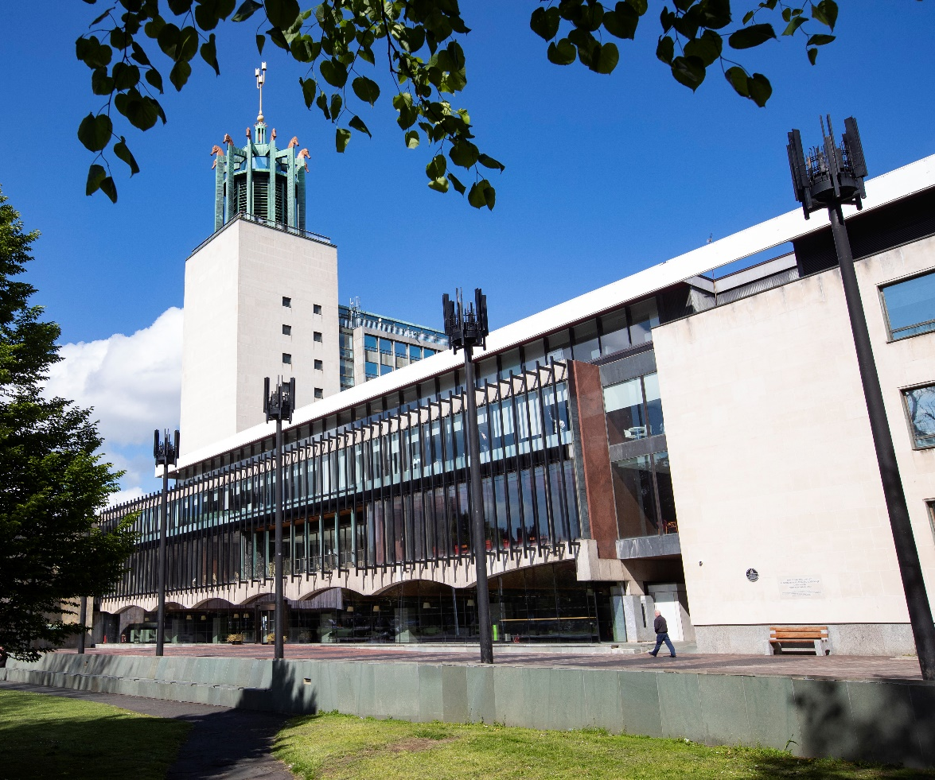

A message from Newcastle City Council
Please tell us what you think by 17 January 2024.

This is an Easy Read summary.
You can find the full document here www.letstalknewcastle.co.uk

Easy Read version created by the Easy Info team
at Skills for People employing people with a learning disability.

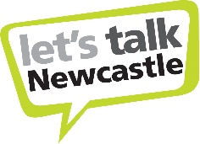
Every year Newcastle City Council has a certain amount of
money to spend

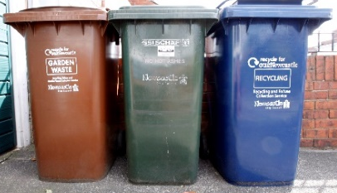
We spend this on services like libraries, collecting bins and supporting people in their homes.

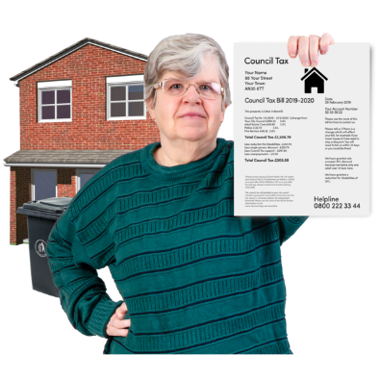

Some of this money comes from Council Tax. Council tax is money which local residents pay for the Council to run services.

Some of this money comes from the Government.

We cannot spend more money than we have.

About 2024 – 2025

The Council will have less money to spend next year. £22 million less than we spent last year.

More people will need to use Council services.

Some people who already use Council services may need more support.

This means it will cost more money to keep the services going.

The Council has some ideas about what it will do
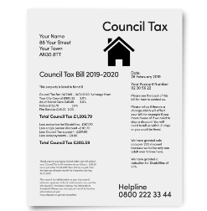

The Council may increase the Council Tax so people pay more.

Some of the Council Tax must be spent on ‘adult social care’. This means it must be spent to support older people, disabled people and people who are ill, or have a mental health problem.

The Council may increase this part of the Council Tax so there is more money for adult social care.

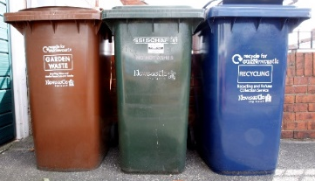
The Council may have to stop some services, or save money on some services.

We will keep asking the Government to give councils more money to help us pay for our services.
The Council wants to know what you think about these ideas.

Please tell us what you think
by 17th January 2024.

You can tell us:

By email letstalk@newcastle.gov.uk

By post FREEPOST Letstalk (you don’t need to use a stamp)

By filling in an online form at www.letstalknewcastle.co.uk

You can ask someone to help you do this: a friend, family member, supporter, or community group.

We are asking local community groups and charities to tell you about our ideas.

You can find out more on the website www.letstalknewcastle.co.uk

Thank you!

