Appendix 3
Map 2 – Columbia Grange:
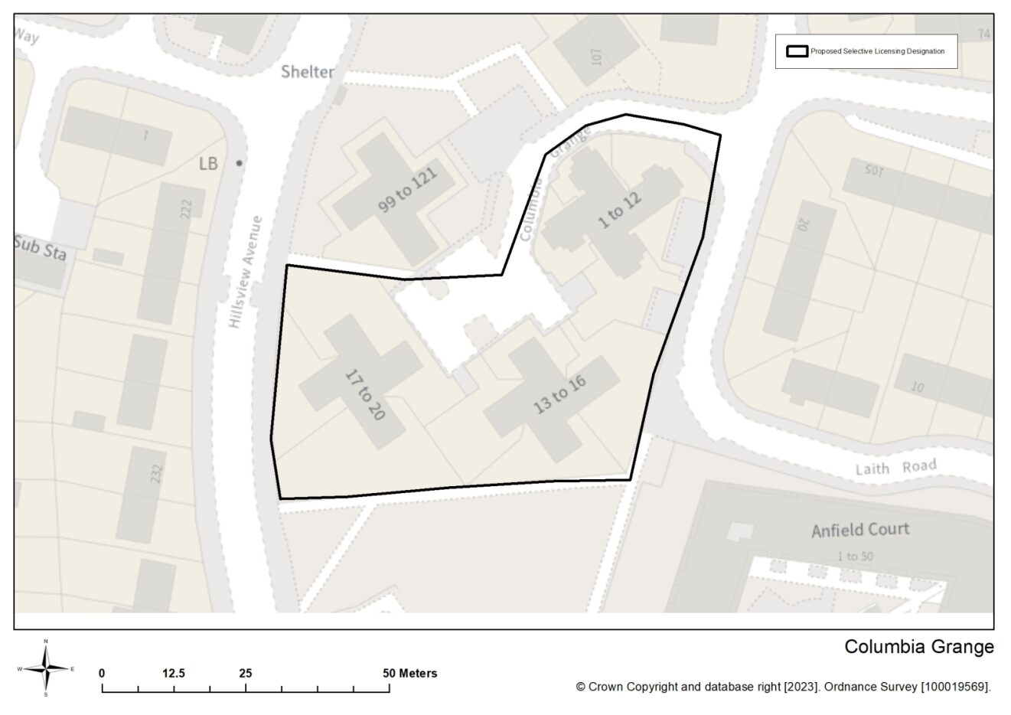
Street | Properties
Columbia Grange | 1 – 20

Map 3 – Cowgate
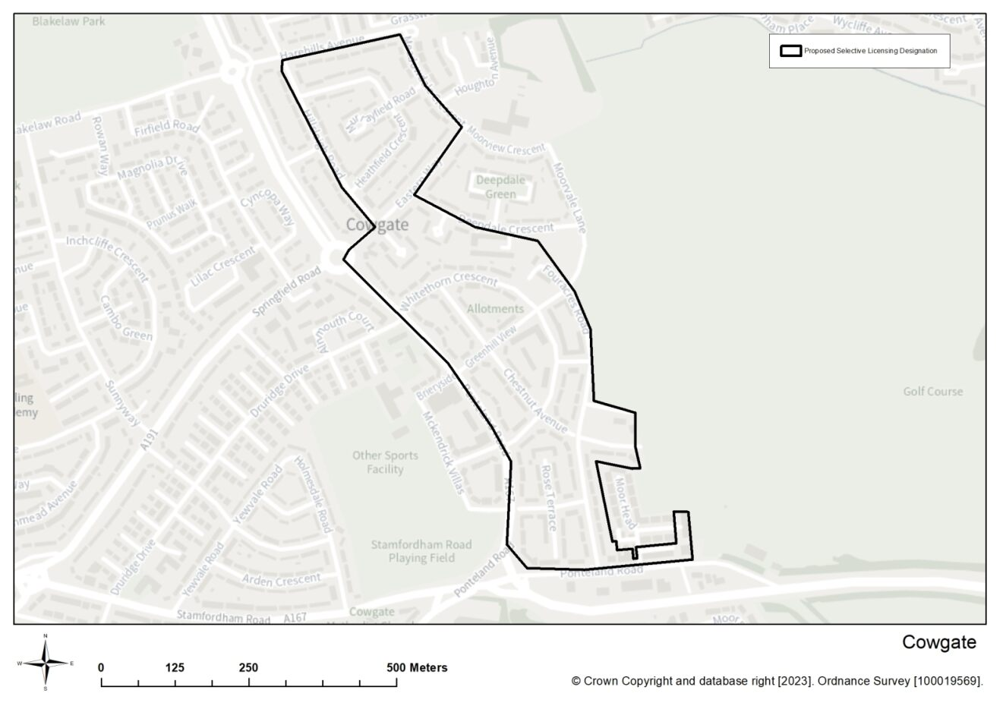
Street | Properties
Aspen Terrace | All properties
Chestnut Avenue | All properties
Deepdale Crescent | Part 2 – 40 even
Eastern Way | Part 2 – 6 even, Part 7 – 54
Fouracres Road | All properties
Greenhill View | All properties
Harehills Avenue | Part, 8 – 46 even
Heathfield Crescent | All properties
High Moor Court | All properties
Hillsleigh Road | Part 2 – 58 even
Link Road | All properties
Mayfield Terrace | All properties
Meadowdale Crescent | Part 1 – 23 odd
Ponteland Road | Part 58 – 252 even, Moorside Court
Rose Terrace | All properties
The Dales | All properties
Whinmoor Place | All properties
Whitethorn Crescent | All properties

Map 4 – Denton Court
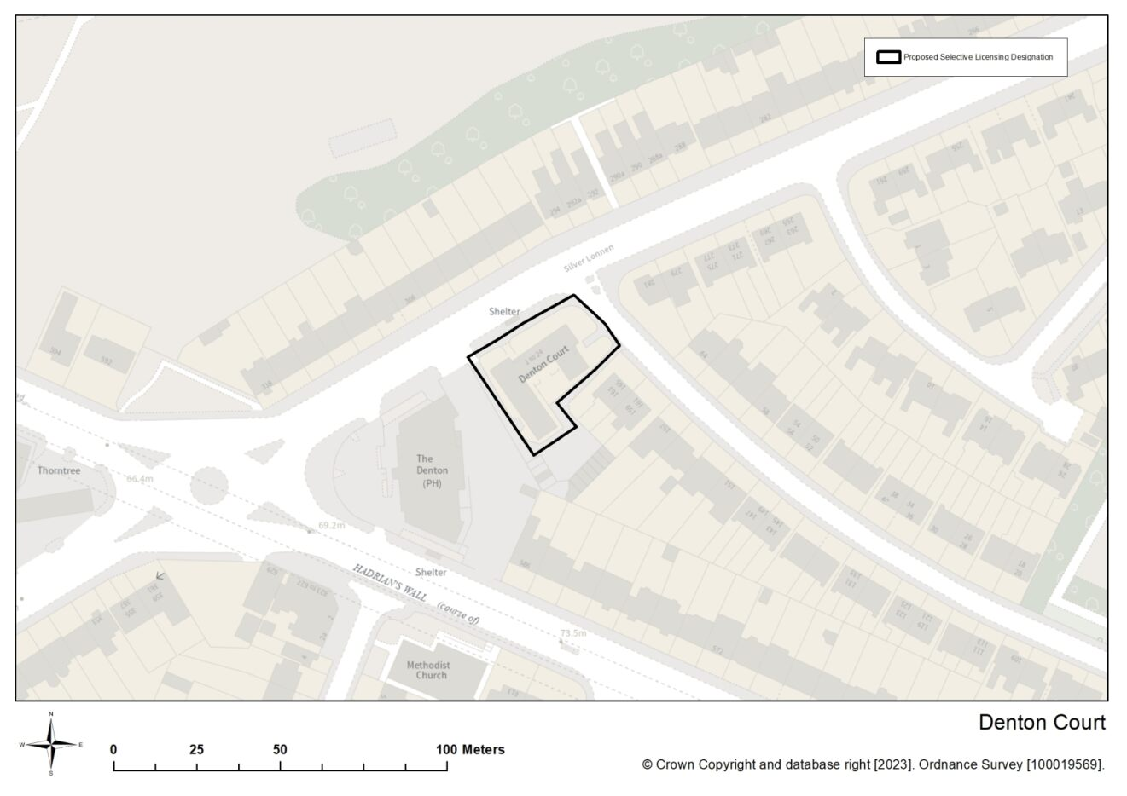
Street | Properties
Denton Court | 1 - 24

Map 5 – HHRS
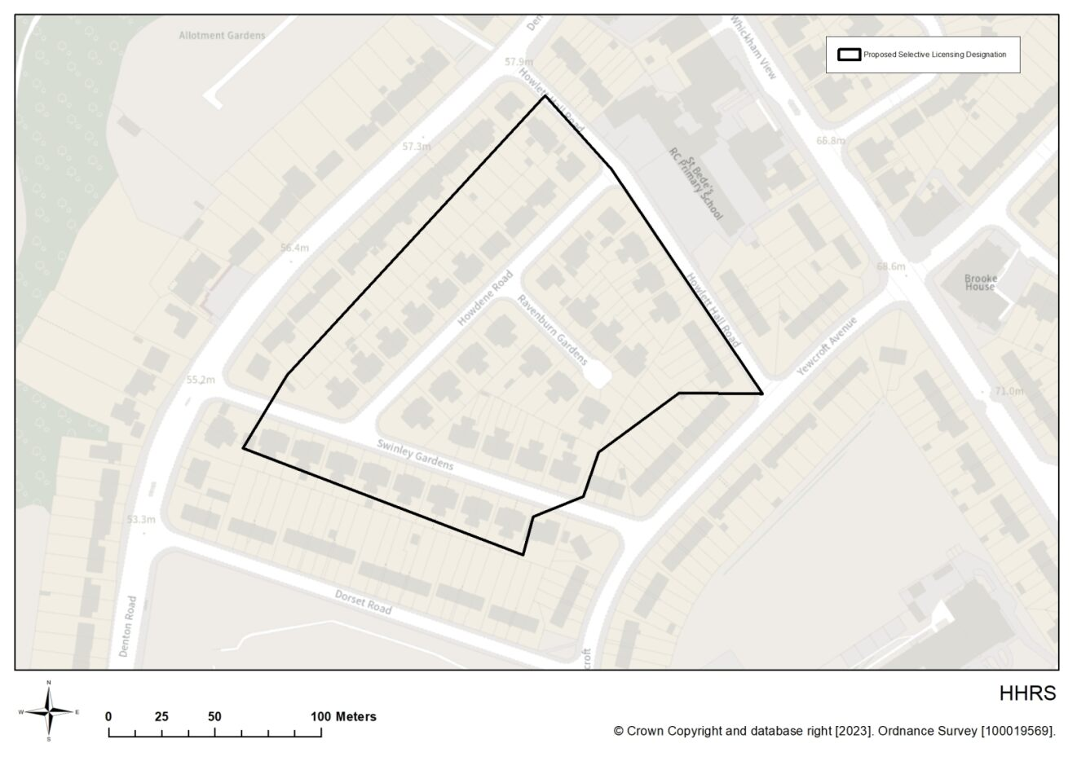
Street | Properties
Howdene Road | All properties
Ravensburn Gardens | All properties
Swinley Gardens | Part, 7 – 42, 43 – 69 odds
Howlett Hall Road | Part, 2 – 46 even

Map 6 – Lemington
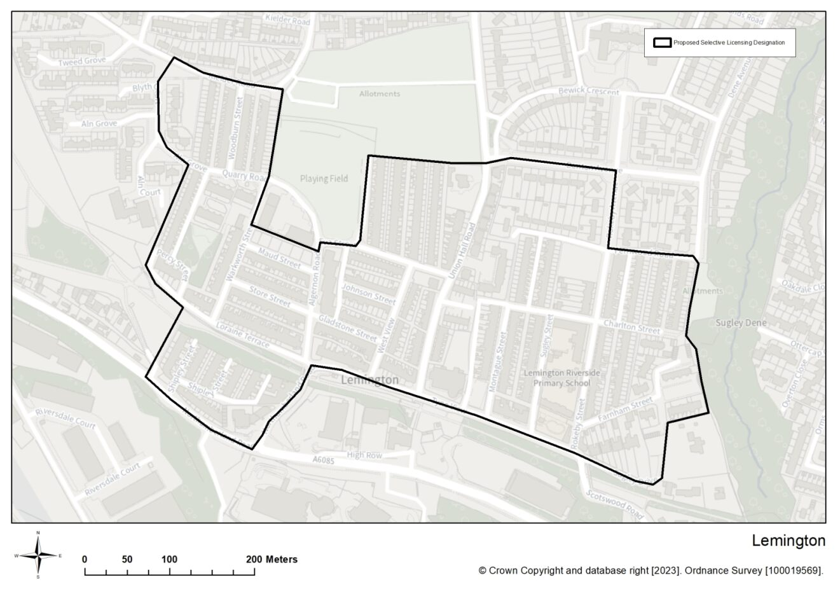
Street | Properties
Addison Road | All properties
Aldeburgh Avenue | All properties
Algernon Road | All properties
Allerdean Close | All properties
Aln Court | All properties
Aln Grove | All properties
Alverston Close | All properties
Apple Close | All properties
Arundel Drive | All properties
Avalon Drive | All properties
Beanley Avenue | All properties
Bells Close | All properties
Bennett Court | All properties
Berwick Close | All properties
Bewick Crescent | All properties
Birchfield Gardens | All properties
Blanchland Avenue | All properties
Blucher Colliery Road | All properties
Blyth Court | All properties
Boyd Terrace | All properties
Brancepeth Close | All properties
Bridgewater Close | All properties
Broadway | All properties
Burnham Avenue | All properties
Bywell Avenue | All properties
Camelford Court | All properties
Carlton Gardens | All properties
Celadon Close | All properties
Centurion Road | All properties
Charlton Street | All properties
Claremont Avenue | All properties
Cobalt Close | All properties
Combe Drive | All properties
Coquet Buildings | All properties
Cranfield Place | All properties
Cranford Gardens | All properties
Crofton Way | All properties
Dene Avenue | All properties
Dene Gardens | All properties
Dene Terrace | All properties
Denton Avenue | All properties
Denwick Avenue | All properties
Doddington Close | All properties
Dunnock Court | All properties
Eldon Place | All properties
Eldon Road | All properties
Ellington Close | All properties
Elmwood | All properties
Eva Street | All properties
Falstone Avenue | All properties
Farnham Close | All properties
Farnham Street | All properties
Fernwood Road | All properties
Flexbury Gardens | All properties
Front Street | All properties
Gladstone Street | All properties
Grasmoor Place | All properties
Hamsterley Crescent | All properties
Hartside | All properties
Heston Court | All properties
Henlow Road | All properties
High Row | All properties
Hillside Avenue | All properties
Honister Close | All properties
Honister Place | All properties
Horncliffe Walk | All properties
Hulne Terrace | All properties
Ingoe Street | All properties
Jade Close | All properties
Johnson Street | All properties
Kielder Road | All properties
Kirkston Avenue | All properties
Lamedon Mill Court | All properties
Layburn Gardens | All properties
Leabank | All properties
Lemington Court | All properties
Lepidina Close | All properties
Lesbury Street | All properties
Letch Way | All properties
Linnel Drive | All properties
Lintzford Gardens | All properties
Lockerbie Gardens | All properties
Loraine Terrace | All properties
Malton Close | All properties
Malvern Court | All properties
Maple Close | All properties
Mapperley Drive | All properties
Marsham Close | All properties
Matfen Close | All properties
Maud Street | All properties
Meadow Road | All properties
Medburn Road | All properties
Melrose Close | All properties
Mercia Way | All properties
Montague Street | All properties
Moorcroft Close | All properties
Moorcroft Road | All properties
Moorway Drive | All properties
Morston Drive | All properties
Moss Close | All properties
Neptune Road | All properties
Neville Road | All properties
Newarth Close | All properties
Newbury Close | All properties
Newdene Walk | All properties
Newton Close | All properties
Nile Close | All properties
Norfolk Way | All properties
North Lea | All properties
Northumberland Road | All properties
Norton Way | All properties
Norwood Road | All properties
Oakdale Close | All properties
Oakenshaw | All properties
Old School Drive | All properties
Orchard Rise | All properties
Orchard Terrace | All properties
Orchard – Leigh | All properties
Ordley Close | All properties
Orminscraig | All properties
Ormiston | All properties
Ormskirk Close | All properties
Ottercap Close | All properties
Ottershaw | All properties
Ottringham Close | All properties
Overton Close | All properties
Pangbourne Close | All properties
Park Rise | All properties
Patina Close | All properties
Percy Street | All properties
Redesdale Close | All properties
Resida Close | All properties
Rokeby Avenue | All properties
Rokeby Street | All properties
Rokeby Villas | All properties
Romsey Grove | All properties
Rydal Road | All properties
Sage Close | All properties
Saint Georges Place | All properties
Saint Georges Terrace | All properties
Saint Vincents Close | All properties
Shamrock Close | All properties
Shelford Gardens | All properties
Shipley Street | All properties
Simpson Terrace | All properties
Southfork | All properties
Southway | All properties
Spencer Terrace | All properties
Stephenson Terrace | All properties
Store Street | All properties
Styford Gardens | All properties
Sugley Drive | All properties
Sugley Street | All properties
Sugley Villas | All properties
Tedham Road | All properties
Tewkesbury Road | All properties
The Crossway | All properties
The Orchard | All properties
The Ramparts | All properties
Tweed Grove | All properties
Tyne View | All properties
Tynevale Terrace | All properties
Union Hall Road | All properties
Valley Court | All properties
Valley View | All properties
Wallington Drive | All properties
Warenmill Close | All properties
Warkworth Street | All properties
Waverley Crescent | All properties
Wedgewood Cottages | All properties
Wellington Street | All properties
West Copperas | All properties
West Denton Close | All properties
West Denton Road | All properties
West Road | All properties
West Spencer Terrace | All properties
West View | All properties
Wingate Close | All properties
Wishaw Rise | All properties
Woodburn Street | All properties
Woodvale Gardens | All properties
Wooler Green | All properties
Woolerton Drive | All properties

Map 7 – West end
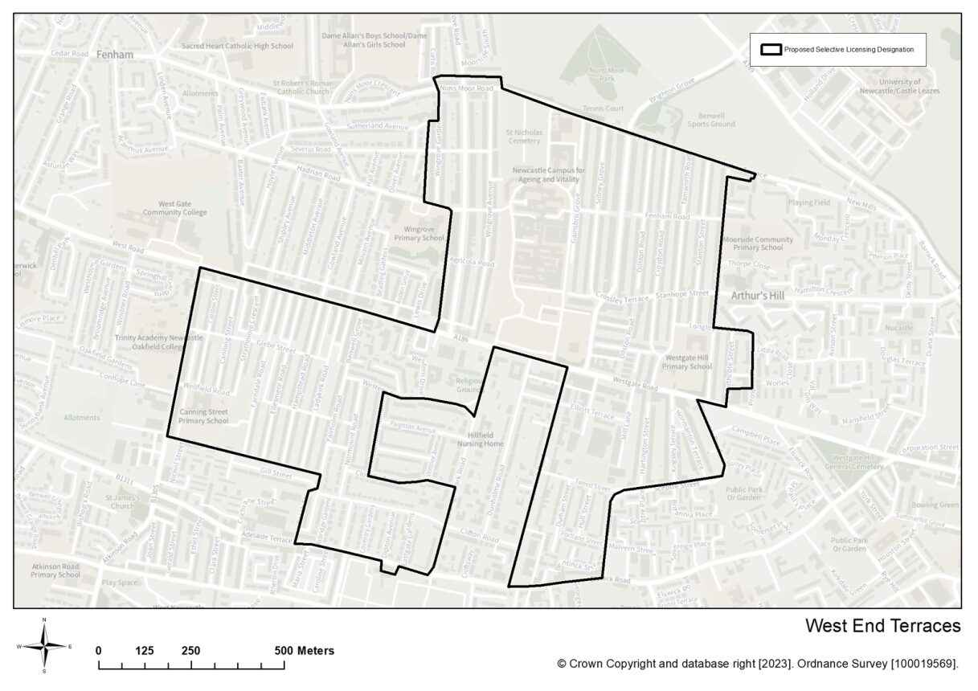
Street | Properties
Agricola Road | All properties
Axbridge Gardens | All properties
Barnesbury Road | All properties
Beaconsfield Street | Part 2 – 100 even, 103 – 319 odd , 314
Beech Street | All properties
Belsay Place | All properties
Bentinck Road | All properties
Benwell Grove | All properties
Bishops Avenue | All properties
Brancepeth Avenue | All properties
Brighton Grove | All properties
Callerton Place | All properties
Canning Street | All properties
Chelsea Grove | All properties
Clifton Road | Part, 51- 53 odd, 54 – 116 even
Cliftonville Avenue | All properties
Clovelly Avenue | All properties
Colston Street | All properties
Condercum Road | Part, 42 – 324 even
Cookson Street | All properties
Coventry Gardens | All properties
Crossley Terrace | All properties
Croydon Road | All properties
Curtis Road | Part, 2
Dilston Road | All properties
Dipton Avenue | All properties
Durham Street | All properties
Eastgate Gardens | All properties
Ellesmere Gardens | All properties
Elliott Terrace | All properties
Elswick Road | All properties
Fairholm Road | All properties
Farndale Road | All properties
Fenham Road | All properties
Gainsborough Grove | All properties
Glebe Street | All properties
Grainger Park Road | Part, 3 – 19, 37 – 71
Graingerville North | All properties
Hadrian Road | Part, 1 – 9
Hamstead Road | All properties
Hartington Street | All properties
Hull Street | All properties
Keldane Gardens | All properties
Kingsley Terrace | All properties
Ladykirk Road | All properties
Longley Street | All properties
Lynnwood Terrace | All properties
Mill Lane | Part, 262, 264
Normanton Terrace | All properties
Normount Avenue | All properties
Normount Gardens | All properties
Normount Road | All properties
Northcote Street | All properties
Nuns Moor Road | Part, 2 – 46, 47 – 55 odd
Philip Street | All properties
Portland Street | All properties
Prospect Place | Part, 7 – 43
Sceptre Street | All properties
Severus Road | Part, 1 – 22
Sidney Grove | All properties
Stanhope Street | Part, 257 – 294
Stanton Street | All properties
Strathmore Crescent | All properties
Studley Terrace | All properties
Tamworth Road | All properties
Tiverton Avenue | All properties
Tweed Street | All properties
Walter Terrace | Part, 7 – 20
Wellesley Terrace | All properties
Wellfield Road | All properties
West Road | Part, 1-75 odd
Western Avenue | Part, 2 – 40
Western Drive | All properties
Westgate Riad | Part, 368 – 585, South View
Wingrove Avenue | All properties
Wingrove Gardens | Part, 7 – 139 odd, 38 – 138 even
Wingrove Road | Part, 1 – 179

