**Children and Families Newcastle – The Community Family Offer Consultation – August 2024**

**1. About Children and Families Newcastle and the Community Family Offer**

Children and Families Newcastle (C&FN) brings services for children and families together to make it easier for them to get the help and support that they want and need, and also so that services and activities that are important to them are easily available in their local area. We want to make sure that children and families only have to tell their story once, and that they get the support they need, when they need it.

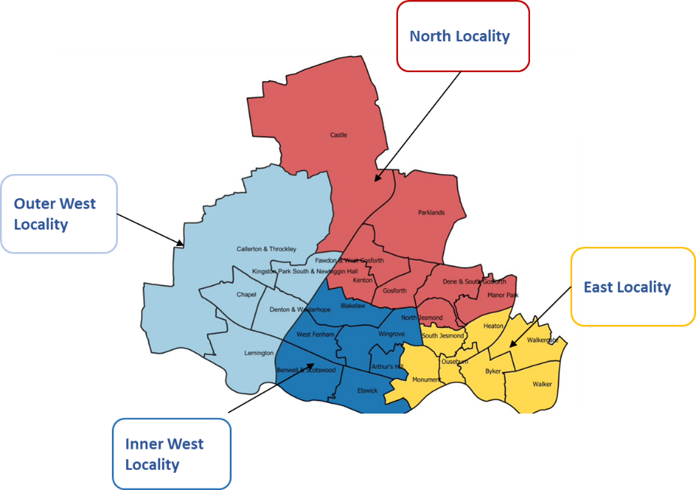The ‘Community Family Offer’ is what we call the approach we take to deliver this. It involves a wide range of agencies working together, including services providing health, welfare, education and social care. The aim is to look at each family as a whole and get the full picture of what a family needs. In Newcastle, we want to group these services together into the four areas shown below:

**2. What we propose doing in future**

We currently have 11 contracts with organisations providing services to children and families. We want to bring them together into four contracts, which will be called:

* Community Family Offer North
* Community Family Offer East
* Community Family Offer Inner West
* Community Family Offer Outer West

We want to do this to improve how these services work together to provide a single ‘offer’ for families, which is effective and responds well to what children and families need in each local area. On the next page is a summary of the key parts which will be included in each contract.

**2.1 Children and Families Hubs**

We want to have a network of vibrant community buildings called ‘Children and Families Hubs.’ These will be conveniently located, accessible to everyone, and familiar to local residents.

The Hubs will offer a wide range of services such as:

* Information, advice and support
* Therapeutic services
* Social activities
* Education and training

They will provide space for different organisations to have meetings. We want them to have both drop-in and bookable activities, and that they will be important centres for family activities during school holidays.

We want the Hubs to help develop ‘peer support’ groups and networks (groups where people with similar experiences can connect and support each other). This could include volunteer groups. We also want there to be opportunities for local residents to get involved in running the Hubs as volunteers or by being employed there.

**2.2 Locality Leadership**

Each area will have a ‘Locality Lead’. This is someone who will lead on how services to support children and families are delivered in each area. They will be important figures who will both oversee these services, and report on how they are being delivered to Newcastle City Council and also the Children and Families Newcastle Integrated Leadership team.

**2.3 Family Partners**

The ‘Family Partner’ role is very important to how this approach to children and family support services will work. The people in these roles will:

* Be a first point of contact for families, keeping up a relationship with them and being someone they can contact if the family needs more support in future.
* Look at each family as a whole, making sure that everyone’s needs – babies, children and adults – are understood and responded to.
* Be a first point of contact for partner organisations, so that these organisations can easily communicate with different services providing support to children and families.

In the Inner and Outer West areas of Newcastle, Newcastle City Council directly employs the Family Partners. In the East and North areas, they are, and will continue to be, employed through other organisations.

**2.4 Responsive Groups, including evidence-based programmes**

In each area, the support on offer will include a range of ‘responsive groups’. These are groups that can provide support with particular needs such as children’s mental health, based on what families need in each area. Some will be ‘evidence-based’, meaning they are mostly based on past experience of what works. Others will be ‘evidence-informed’, where the way services are delivered depends on a mixture of past experience, the judgement of the people delivering the services, and the views and experiences of the children, adults and families using them.

As well as the responsive groups, there will also be a range of evidence-based parenting programmes (courses that help people learn about different aspects of being a parent, such as what children need at different stages of development), and in some areas there may be other parenting programmes, courses and workshops. We also want to see volunteers being involved in delivering this support, and again this will depend on what families in each area need.