**Welbeck Road Evangelical Church**

**Do you need this in an alternative language or format? Please email:** [**propertylicensing@newcastle.gov.uk**](mailto:propertylicensing@newcastle.gov.uk)

**Date:** **Wednesday 3 September 2025**

**Time:** 5.00pm – 7.00pm

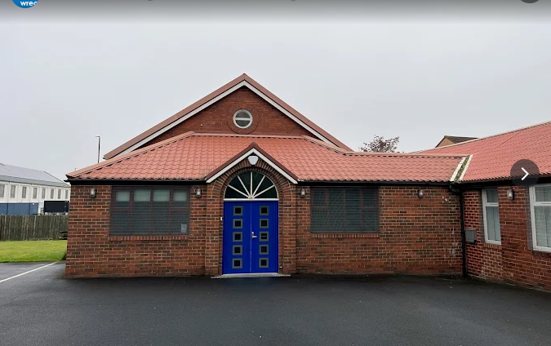**Location:** Corner of Allendale Road, Welbeck Road Newcastle upon Tyne, NE6 2HU

**Venue Car Park**

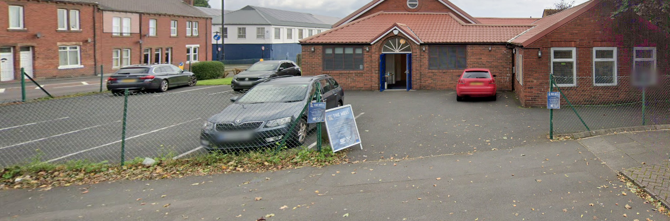

* Access to this car park is off Allendale Road.
* This is a free car park to people using the church.
* The car park is located at the front of the building.
* The car park type is open air / surface.

**Why is this session happening?**

The Property Licensing team have set up events to allow members of the public to have their say in the consultation on a proposed selective licensing scheme. The licensing scheme means that all private landlords in the area covered by the scheme must have a licence from the Council to rent out property. The aims are:

1) to improve the private rented market, because properties must be of a decent standard before landlords can rent them out, and

2) to give tenants more confidence that houses and flats in the area covered by the scheme will be healthy and safe to live in. There are seven 'selective licensing' areas already operating in Newcastle. We are consulting on our proposals which could see the renewal of selective **licensing schemes** in the following areas for another five years.

* Byker Old Town
* Allendale Road
* Greater High Cross

All private rented properties within a selective licensing area require a licence unless they are otherwise exempt. To learn more about the licensing scheme visit: <https://new.newcastle.gov.uk/property-licensing-schemes-newcastle>

**What will happen in the session?**

The event will have a presentation between 5-5.30pm this will be followed by a Question-and-Answer session. For more information go to [Newcastle Selective Property Licensing in 2026 Byker, Allendale Road and Greater High Cross](https://forms.office.com/Pages/ResponsePage.aspx?id=wLSfsgQNn0q0YsEpSx4bRwM_WewsuG1EkyEh3CVRL6pUMFA2UVdBODVGVUZETkI2RjAzSFRHR0lTTS4u)

**How do I get to Welbeck Road Evangelical Church?**

Follow this link to see the Welbeck Road Evangelical Church on Google Maps: [Welbeck Road Evangelical Church - Google Maps](https://www.google.com/maps/place/Welbeck+Road+Evangelical+Church/@54.9733026,-1.5724183,595m/data=!3m1!1e3!4m14!1m7!3m6!1s0x487e70f4cc50cd33:0xc4684f46c77a9d37!2sWelbeck+Road+Evangelical+Church!8m2!3d54.9732995!4d-1.5698434!16s%2Fg%2F1v7py0vz!3m5!1s0x487e70f4cc50cd33:0xc4684f46c77a9d37!8m2!3d54.9732995!4d-1.5698434!16s%2Fg%2F1v7py0vz?entry=ttu&g_ep=EgoyMDI1MDcyNy4wIKXMDSoASAFQAw%3D%3D)

**Public Transport**

Welbeck Road Evangelical Church is located on Allendale Road, Byker. It is within 15-minute walking distance of Byker Metro Station with trains running from Monument to Byker. The nearest bus stop is on Welbeck Road within a minute’s walk.

**If I have any questions before the event, who can I talk to?**

If you have any questions ahead of the event, contact our team on: [**propertylicensing@newcastle.gov.uk**](mailto:propertylicensing@newcastle.gov.uk) 

**If I have any questions at the event, who can I talk to?**

At the event we will have Officers who will introduce themselves to you at the door. You can ask them any questions about the event.

**Thank you!**