**West End Library and Community Hub**

**Do you need this in an alternative language or format? Please email:** [**propertylicensing@newcastle.gov.uk**](mailto:propertylicensing@newcastle.gov.uk)

**Date:** **Wednesday 10 September 2025**

**Time:** 5–7pm

**Location:** Condercum Road, Benwell, Newcastle Upon Tyne, NE4 9JH

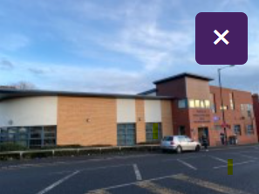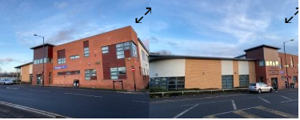**Venue Car Park**

* Parking is free for all users.
* The car park is located to the left-hand side as you face the venue.
* The car park type is open air/surface.
* Parking spaces for Blue Badge holders cannot be booked in advance.
* There is / are 2 Blue Badge parking bay(s) within the car park.
* The route from the car park to the entrance is accessible to a wheelchair user with assistance.
* Assistance may be required because there is/are slopes/ramps.
* There is a dropped kerb between the car park and the venue.

**Why is this session happening?**

The property licensing team have set up events to allow members of the public to have their say in the consultation on a proposed selective licensing scheme. The licensing scheme means that all private landlords in the area covered by the scheme must have a licence from the Council to rent out property. The aims are:

1) to improve the private rented market, because properties must be of a decent standard before landlords can rent them out, and

2) to give tenants more confidence that houses and flats in the area covered by the scheme will be healthy and safe to live in. There are seven 'selective licensing' areas already operating in Newcastle. We are consulting on our proposals which could see the renewal of selective **licensing schemes** in the following areas for another five years.

* Byker Old Town
* Allendale Road
* Greater High Cross

All private rented properties within a selective licensing area require a licence unless they are otherwise exempt. To learn more about the licensing scheme visit: <https://new.newcastle.gov.uk/property-licensing-schemes-newcastle>

**What will happen in the session?**

The event will have a presentation between 5-5.30pm this will be followed by a Question-and-Answer session. For more information go to: [Newcastle Selective Property Licensing in 2026 Byker, Allendale Road and Greater High Cross](https://forms.office.com/Pages/ResponsePage.aspx?id=wLSfsgQNn0q0YsEpSx4bRwM_WewsuG1EkyEh3CVRL6pUMFA2UVdBODVGVUZETkI2RjAzSFRHR0lTTS4u)

**How do I get to West End Library?**

Follow this link to see the West End library on Google Maps:

[West End Customer Service Centre Library - Google Maps](https://www.google.com/maps/place/West+End+Customer+Service+Centre+Library/@54.9714143,-1.6601085,595m/data=!3m2!1e3!4b1!4m6!3m5!1s0x487e7712ed287059:0xf61bd94cb7709c7b!8m2!3d54.9714143!4d-1.6601085!16s%2Fg%2F11xtwjsms?entry=ttu&g_ep=EgoyMDI1MDcyNy4wIKXMDSoASAFQAw%3D%3D)

**Public Transport**

There are good bus links to the library. The stop is named Benwell Lane-Condercum Road, and it's a short walk from the library. Several bus routes serve this stop.

**Where are the toilets?**

There is an accessible toilet approximately 8m (8yd 2ft) from the main entrance. The accessible toilet is located to the right as you enter.

There is level access to this accessible toilet.

**If I have any questions before the event, who can I talk to?**

If you have any questions ahead of the event, contact our team on: [**propertylicensing@newcastle.gov.uk**](mailto:propertylicensing@newcastle.gov.uk) 

**If I have any questions at the event, who can I talk to?**

At the event we will have Officers who will introduce themselves to you at the door. You can ask them any questions about the event.

**Thank you!**