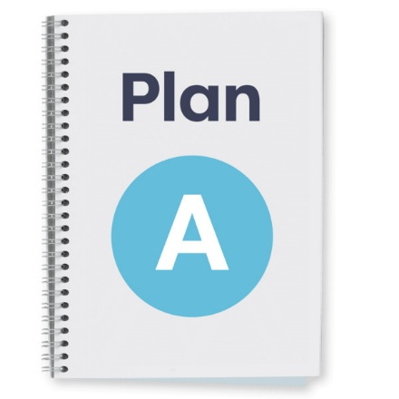
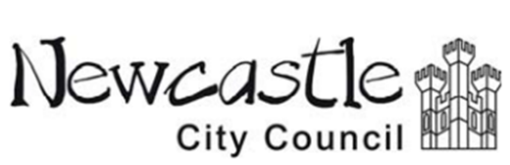
Our plan to spend and save money

Newcastle City Council have a new plan to spend and save money for the next 3 years.


Things cost more money now. There have already been cuts to services.

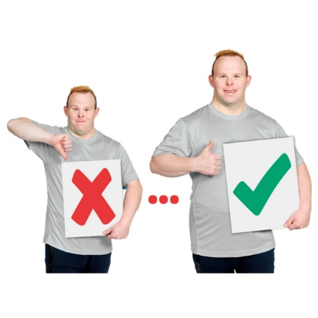
We want to find new and better ways to run services. This will help us save money and keep to our budget. It will help us make sure people get the services they need.
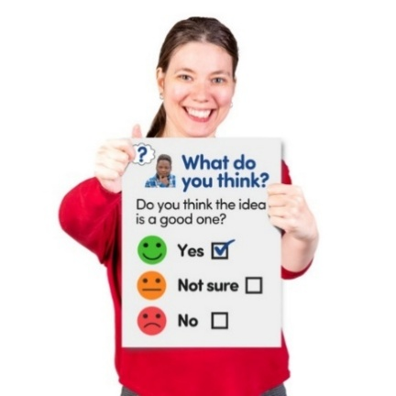
We want to find out what you think about our plan to spend and save money. We want to know what is important to you so we can choose the best plan.

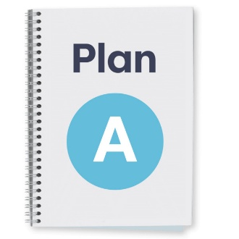

This is our plan for how we will spend our money for the next 3 years.

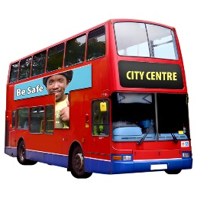
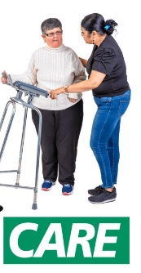
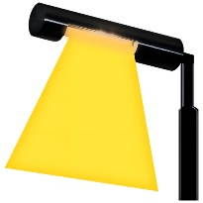
Spend £328 million on everyday services like buses, social care, street lights and libraries.

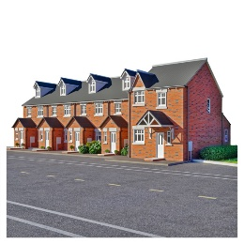

Spend £134 million on big things like roads, housing and schools.

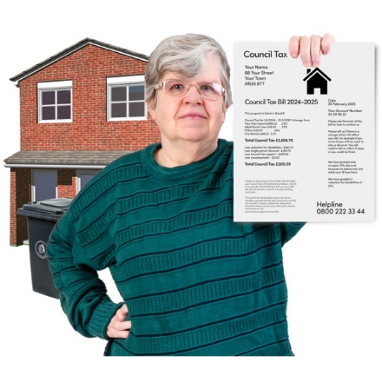
Put up Council Tax by 2.99%.
Put up the adult social care charge by 2%. This is part of the Council Tax people pay.


There is a lot more information about our plans on the internet.
- Change and Innovation – a summary of our 2026-27 savings proposals
- Medium-Term Financial Plan for 2026-2027 to 2028-2029 – Revenue and Capital Plan
- Council Tax and Adult Social Care Proposal – Integrated Impact Assessment (IIA)
- View the MTFP Cabinet papers
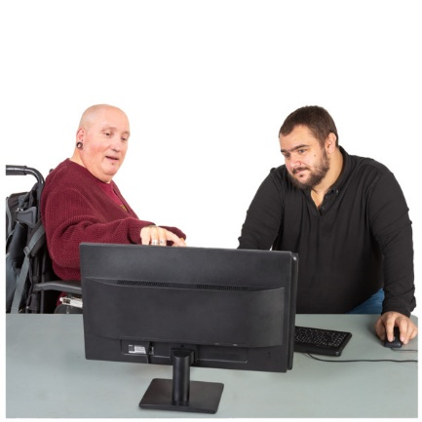
You might need to ask someone to help you understand.

Important information about the questions
You can choose to answer the questions.
You can just answer the questions that you want to answer.
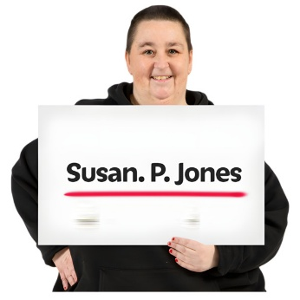

We do not ask for your name. This means that no one will know who you are.


You can find out more about this on our website: https://www.letstalknewcastle.co.uk/page/privacy-policy

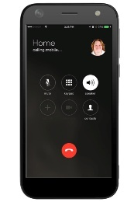

If you have any questions, please email us at letstalk@newcastle.gov.uk or call us on 0191 278 7878.



Please tick the boxes or write your answer in the box. Each question will tell you how many boxes you can tick, or where to write your answer.

1. Do you agree with our plan for spending and saving money over the next 3 years? Tick one box.
Yes No



2. Do you think this is a fair way to do it? This means we save money but people can still get the Council services they need. Tick one box.
Yes No

3. Please tell us what you think about our plans in this box. Tell us any good or bad things about our plan.
4. Do you agree with our plan to ask people to pay more Council Tax and more for the social care charge? Tick one box.
Yes No

5. Do you think this is a fair way to do it? This means we can keep services going and we do not have to make cuts to services. Tick one box.
Yes No

6. Please tell us what you think about this part of our plan. Tell us any good or bad things about this part of our plan.

7. What is important to you?
On the next 3 pages you will see a list of the different ways we will change how we run services.
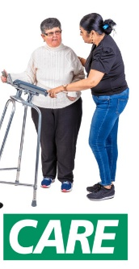

Please tick up to 3 boxes to tell us what is most important to you.

Spend money on important services like roads, bins and social care.

Spend money on the arts to bring more money in to Newcastle.
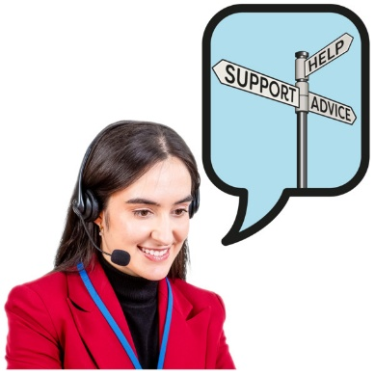
Use technology to make it easier for people to contact us and get our help.

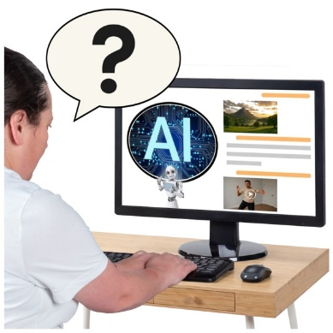
Teach our staff to use Artificial Intelligence to help them do more.


Collect and use information to check how we are doing and make sure we do things in the best way.
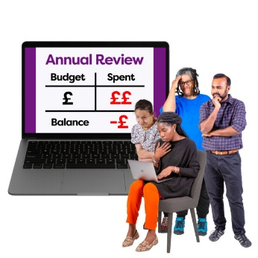
Think about how we organise our services to make sure we use our money in the best way.
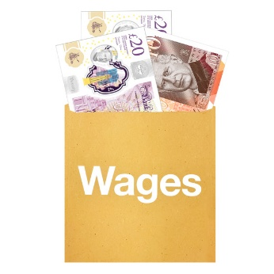
Make our support services simpler. This is things like paying staff and giving people jobs.
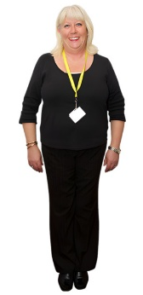
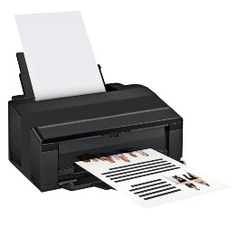
Make sure we use our money in the best way when we need to pay for things like agency staff or when we buy equipment.


Make our systems work together. This is things like how we pay staff, manage our money, buy things and support our staff.

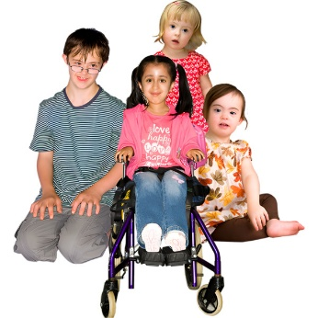
Look after children who need us most in a way that gives us the best value for our money.

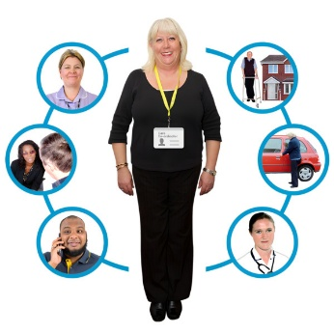
Work in a new way to make sure we can support everyone that needs us. This is for adult social care, education and children with support needs or disabilities.
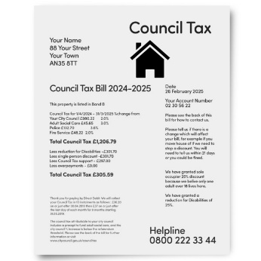
Ask people who pay Council Tax to pay a bit more so we do not need to cut services.

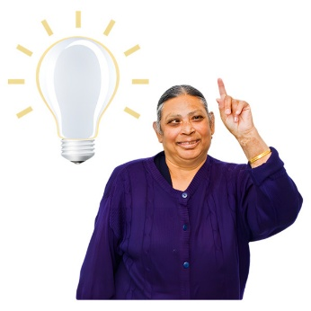
8. Please tell us any other ideas you have to help us save money or spend money better.


9. Please tell us anything else you want to say about our plans.


More questions about you
Please tell us more about you.


1. What is your sex?
Please tell us if you are male or female, or you can say how you like to describe yourself.


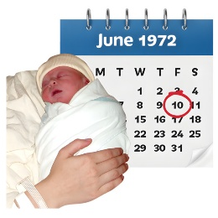
2. Is your gender the same as the sex you were given when you were born? Tick one box.
Yes No
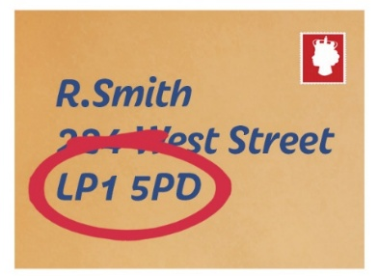
3. What is your postcode?


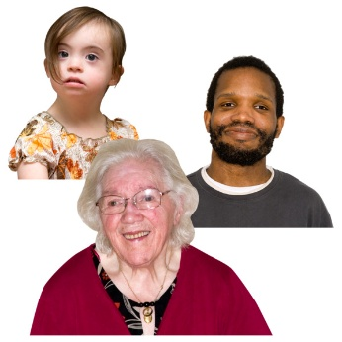
4. How old are you?

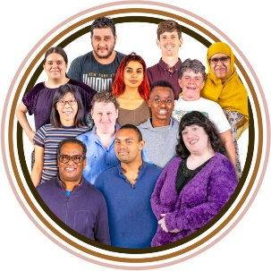
4. Please tell us your ethnic group, this means your culture or background.


6. Do you have a disability? Tick one box.
Yes No


Thank you.


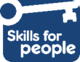

Made by the Easy Info Team at Skills for People, employing people with a learning disability.

