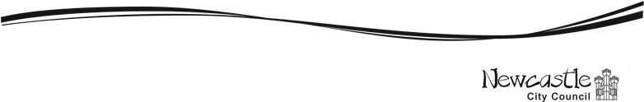

Newcastle City Council XXXX 2026
Proposal for Public Space Protection Order

Background Information
Newcastle upon Tyne: Public Spaces Protection Order
Background Information
Introduction
Newcastle City Council is facing some problems with anti-social behaviour. People who live and work in the city have raised concerns, and the Council wants to make sure Newcastle stays a safe and welcoming place. To help with this, the Council plans to put rules in place to reduce anti-social behaviour and to make sure support is available for people who need it.

The Council will be asking the public for their views in April. This is about a plan to bring in an updated Public Space Protection Order (PSPO). Council officers and members have already talked about this, and they want to hear what others think as well. They decided that a full consultation is needed so the final decision is fair and based on good evidence.

If the new PSPO is introduced, it will update two current orders: Drinking in public spaces order and the Dog Control Order. These orders already set rules on drinking alcohol in public places and how dog owners should behave. This document explains each type of behaviour the Council wants to include.

We want to know what you think about having a PSPO. At the end of this document, you can find information about the different ways you can share your views.

What is a Public Space Protection Order (PSPO)?
Public Space Protection Orders (‘PSPOs’) were created by the Anti-Social Behaviour, Crime and Policing Act 2014, Chapter 2, Part 4 which came into force on 20 October 2014. PSPO’s can be used to regulate activities in public places that can have a negative effect on the quality of life of those in the locality. They are designed to ensure that the law abiding majority can use and enjoy public spaces, safe from anti-social behaviour. Further information can be found on the following links.

http://www.legislation.gov.uk/ukpga/2014/12/part/4/chapter/2/enacted

https://www.gov.uk/government/uploads/system/uploads/attachment_data/file/352562/ASB_Guidance_v8_July2014_final__2_.pdf

Local authorities have the power to use these orders to help in tackling anti-social behaviour. The order works by imposing conditions on the use of that area which apply to everyone. It is an offence for a person to fail without reasonable excuse to comply with the order. The orders have effect for up to three years and can be extended.

Proposed area to be covered by the PSPO
It is proposed that certain conditions in the PSPO will cover the full Newcastle upon Tyne local authority area, and some will cover the City-Centre. The maps of these areas are shown below. These areas are known as the ‘Restricted Area’.
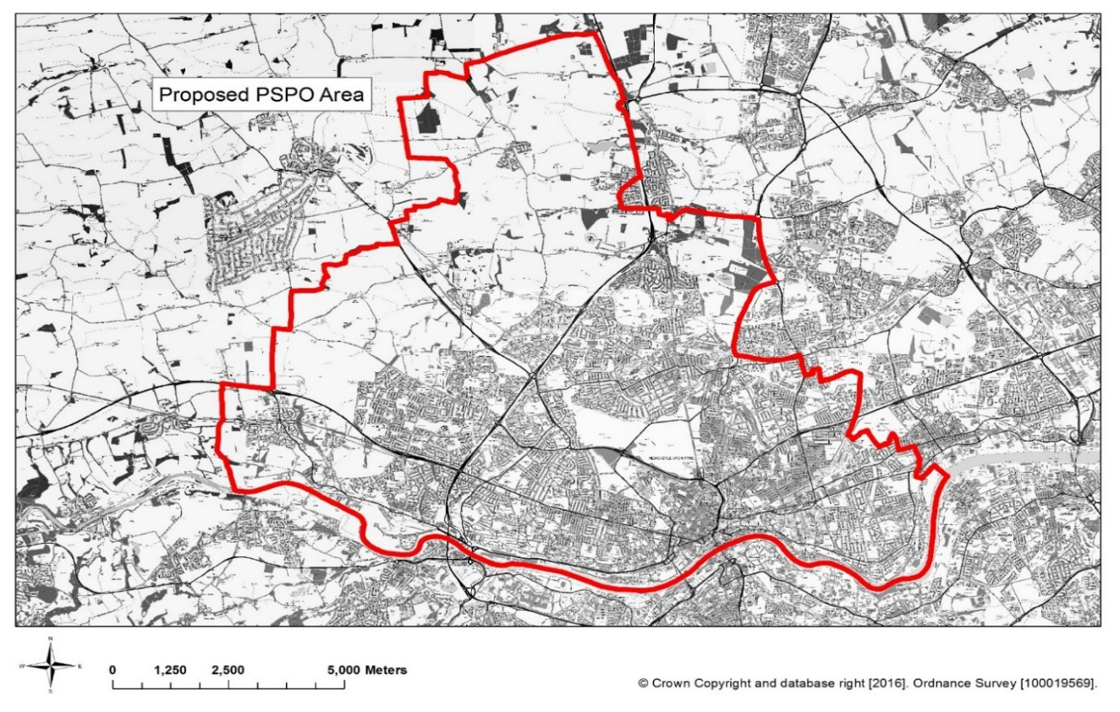

Newcastle Upon-Tyne – Entire locality (image above)
What will be included in the PSPO for Newcastle?
The Council’s proposed PSPO would encompass activities which are currently covered by existing orders under previous legislation together with other activities which are currently not subject to orders. The activities are detailed below:

Drinking alcohol in public places
Existing PSPO conditions surrounding drinking alcohol in public places are to stop problems like noise, fights, or people causing antisocial behaviour because of alcohol. These rules are not meant to stop normal, peaceful activities. For example, families having a picnic in the park or people enjoying a drink in their own garden.
The new public spaces protection order is meant to have one set of rules for the whole area. The aim is to stop alcohol related behaviour that is upsetting or harmful to local communities.
Those that are causing issues, a person shall stop consuming alcohol or surrender any containers (sealed or unsealed) which are reasonably believed to contain alcohol, when required to do so by an Authorised officer.

Dog Control Orders
Dog Control Orders regulate a number of offences including the control of dogs on leads, allowing a dog to enter land from which dogs are excluded and dog fouling. There is currently a Dog Control Order in place for the whole of the Council’s area. The proposed PSPO would include the behaviour currently regulated by the Dog Control Order so that there is one order for all of the behaviours to be regulated. The new PSPO would replace these orders allowing enforcement action to be taken against those dog owners allowing this type of behaviour.

What happens next?
To help us decide whether to have a PSPO, we are consulting to provide you with the opportunity to tell us what you think of the proposal. There are a number of ways you can tell us your views.

This leaflet gives some detailed background to the proposals. This information can be found on line together with a copy of the questionnaire and a copy of the code of conduct for the Enforcement Officers at: xxxxxxxxxxxxxxxxxxxxxxxxxxx

- Complete an online questionnaire at: xxxxxxxxxxxxxxxxxxxxxxxxxxxxxxxxxxxxxxx

- Complete a paper questionnaire: copies are available upon request or can be downloaded from the website and send it to:

Joseph.Catchpole@newcastle.gov.uk

- Write to us at the address above (please mark it ‘Public Space Protection Order consultation’.

This consultation will close on 11/05/2026
Newcastle City Council will make the final decision about the Public Space Protection Order. Details of the decisions will be published on the Councils website.

If you need this information in another format or language, please email:
Joseph Catchpole – Community Safety Development Officer on Joseph.catchpole@newcastle.gov.uk

