

Polling District and Polling Place Review 2026

Blakelaw and Cowgate Ward

Parliamentary Constituency: Central and West

(Proposed) Polling District Changes: C02, C03

This document provides details of the review, along with the initial recommendations and comments of the (Acting) Returning Officer (ARO). Also, the election rules require the ARO to decide how many polling stations are required for each polling district and the ARO must allocate electors to the polling stations in such manner as they think most convenient.

This review is undertaken pursuant to Schedule A1 of the Representation of the People Act 1983. The review is an interim review limited to those polling districts affected by the ongoing Community Governance Review and is being conducted in accordance with the statutory requirements applicable to polling district and polling place reviews.

These recommendations will be open to all residents, stakeholders, and any interested parties. We shall be seeking representations from local disability groups on the accessibility and suitability of polling places. Any comments should be addressed in the first instance to pollingplaces@newcastle.gov.uk where they will be collated on behalf of the (Acting) Returning Officer.

We considered the following factors:

- Identifying new polling places: We will look for new polling places in areas where the existing provision is unsuitable or unavailable.

- Feedback: We will consider feedback received following recent elections, consultation from members of the public, elected members, and other stakeholders.

- Accessibility: We will try to ensure that every polling place is accessible to electors with disabilities.

- Facilities: We will make sure that all electors have such reasonable facilities for voting as are practicable in the circumstances.

- Elector numbers: We will try to comply with the Electoral Commission guidance on the maximum number of electors that should be allocated to a polling station which should not exceed 2,250.

- Future housing developments: We will consider the impact of proposed housing developments on polling station electorates.

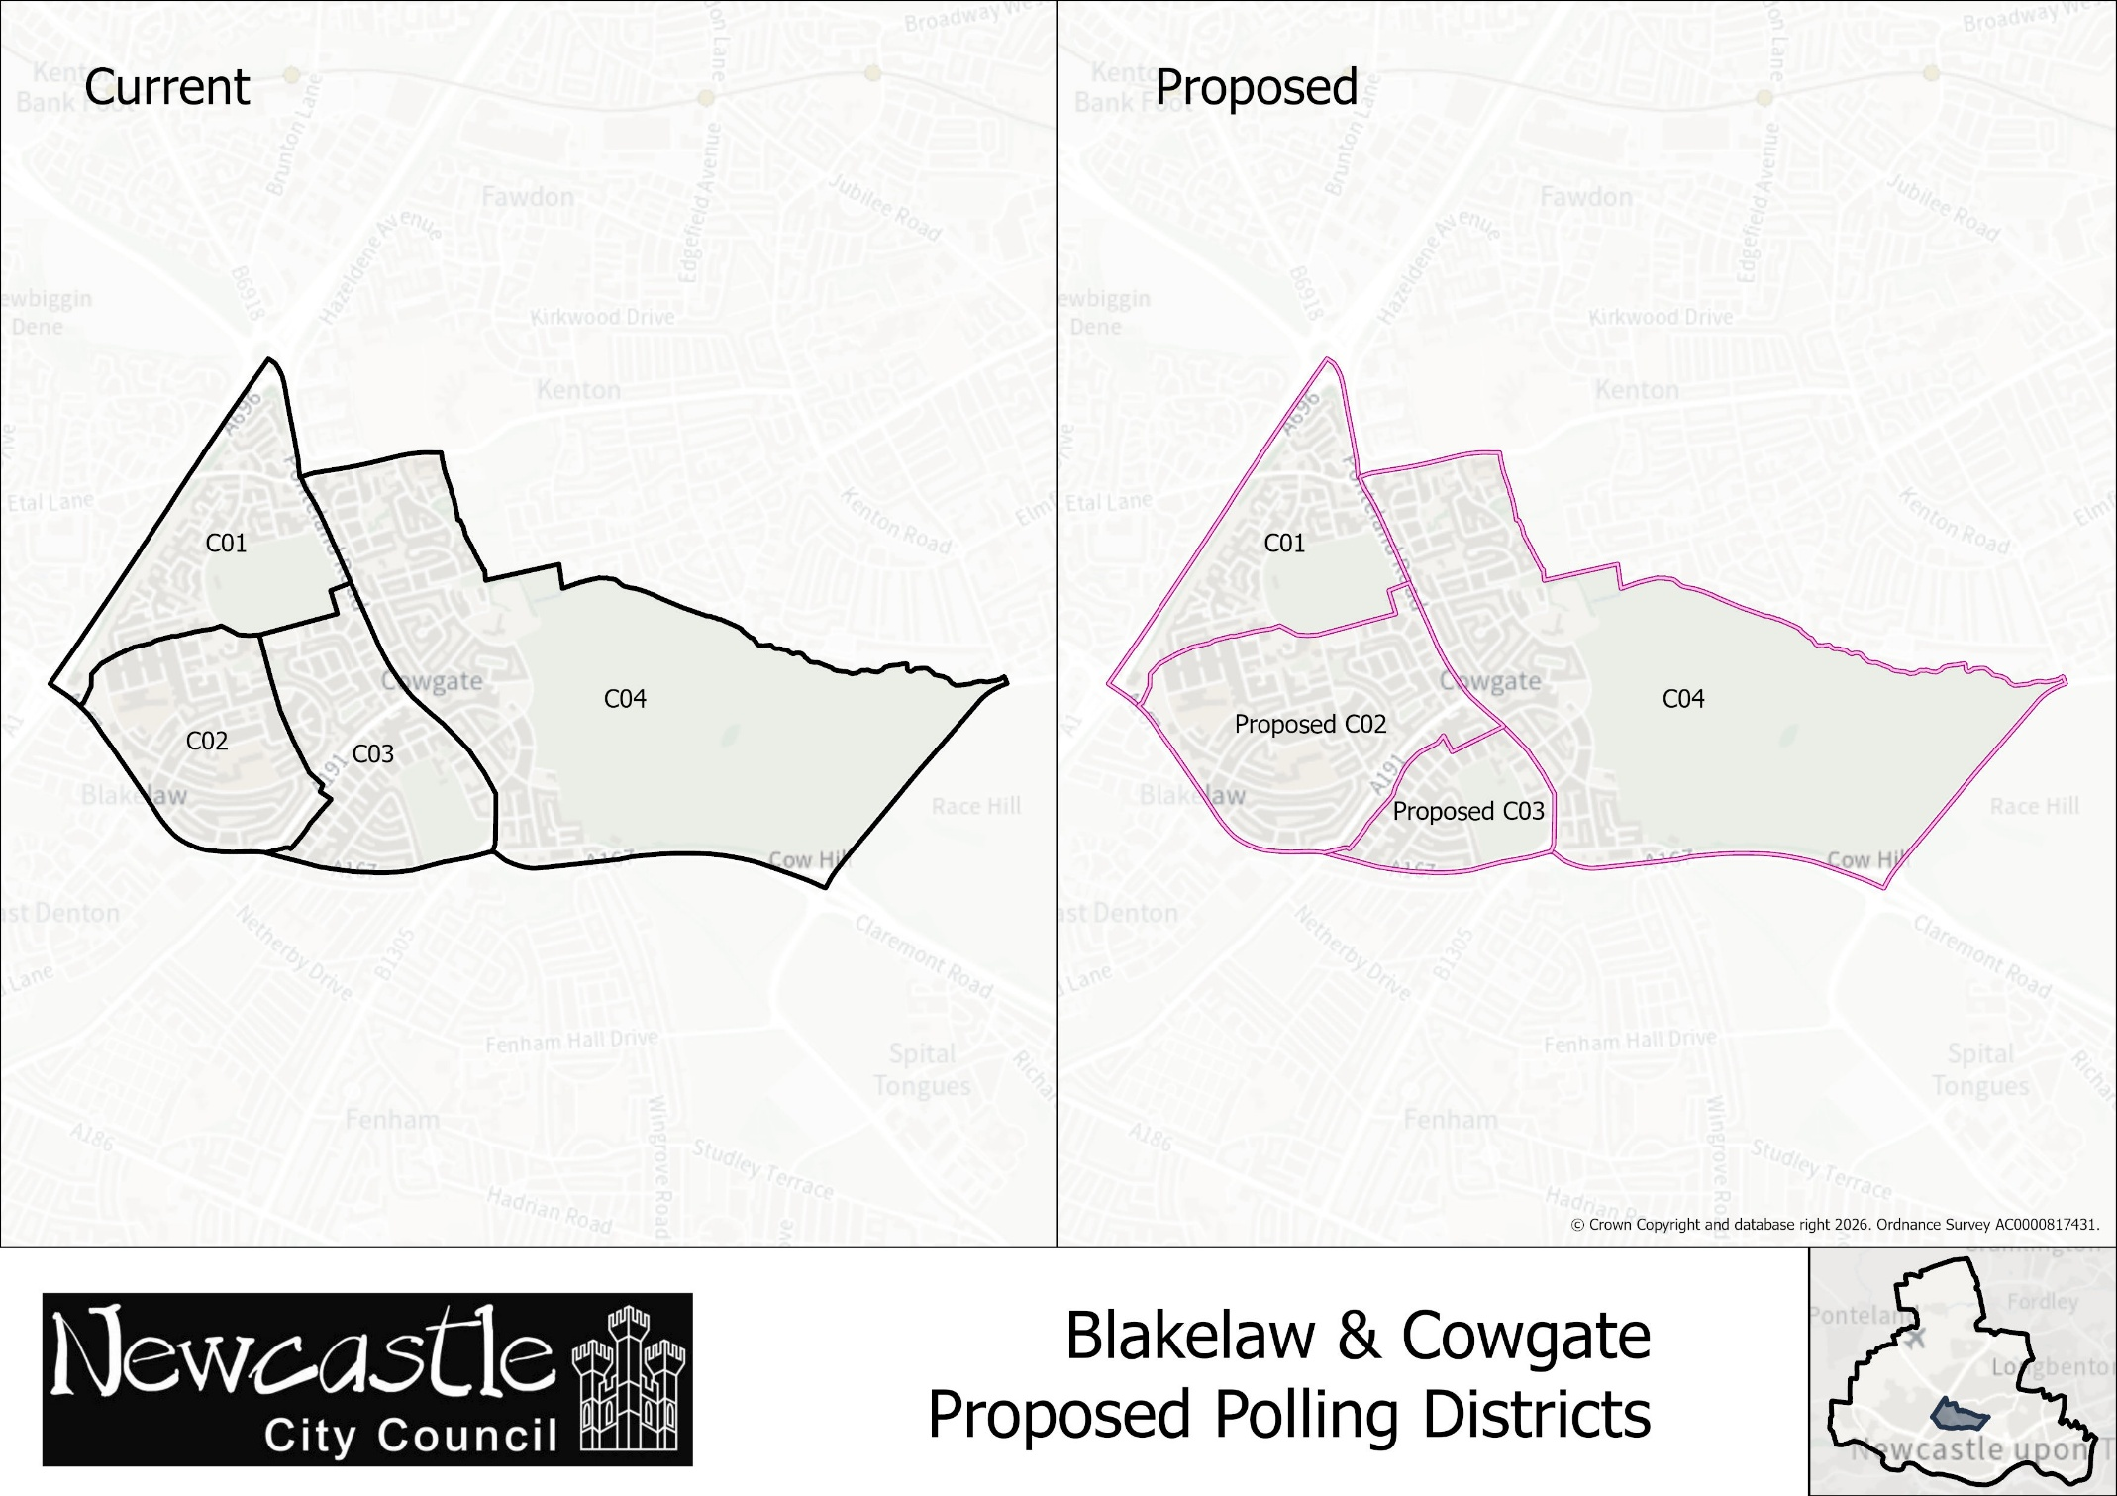
Current Polling District | Current Polling Place
C02 | Blakelaw Community Church, Cragston Way, NE5 3SW
Proposed Polling District | Predicted Polling Station  Electorate | Proposed Polling Place
C02 | 2,142 | Blakelaw Community Church, Cragston Way, NE5 3SW
Considerations and Proposals
Following preparation for this review, it has been identified that certain changes approved as part of the previous Polling District and Polling Place Review in 2025 were not subsequently reflected in the electoral register as intended. Specifically, the intended change to split the former C02 polling district. As a result, the polling district structure currently in operation has remained substantially unchanged from the arrangements that existed prior to that review and the affected streets and electors have remained allocated to the same polling districts and polling stations as before.

As the Council is now undertaking an interim review of polling districts and polling places, it has been deemed appropriate to regularise the formal position and the (A)RO proposes that the C02 polling district should be amended to align with the existing boundary for Blakelaw parish ward. This proposal is not expected to result in any practical change for electors in Blakelaw and Cowgate.

The proposal would also help regularise parish election arrangements by aligning polling district boundaries with parish ward boundaries, thereby reducing complexity and supporting the effective administration of elections.

The polling place will remain unchanged.

Blakelaw and Cowgate Ward
Polling District C02

Blakelaw and Cowgate Ward
Polling District C03

Current Polling District | Current Polling Place
C03 | English Martyr’s Community Centre, Druridge Drive, NE5 3JR
Proposed Polling District | Predicted Polling Station  Electorate | Proposed Polling Place
C03 | 631 | English Martyr’s Community Centre, Druridge Drive, NE5 3JR
Considerations and Proposals
Following preparation for this review, it has been identified that certain changes approved as part of the previous Polling District and Polling Place Review in 2025 were not subsequently reflected in the electoral register as intended. Specifically, the intended change to split the former C02 polling district. As a result, the polling district structure currently in operation has remained substantially unchanged from the arrangements that existed prior to that review and the affected streets and electors have remained allocated to the same polling districts and polling stations as before.

As the Council is now undertaking an interim review of polling districts and polling places, it has been deemed appropriate to regularise the formal position and the (A)RO proposes that the C03 polling district should be amended to align with the existing boundary for North Fenham parish ward. This proposal is not expected to result in any practical change for electors in Blakelaw and Cowgate.

The proposal would also help regularise parish election arrangements by aligning polling district boundaries with parish ward boundaries, thereby reducing complexity and supporting the effective administration of elections.

The polling place will remain unchanged. It is shared with polling district Y04.

