

Polling District and Polling Place Review 2026

Castle Ward – E01 and E02

Parliamentary Constituency: Cramlington and Killingworth

(Proposed) Polling District Changes: E01, E02

This document provides details of the review, along with the initial recommendations and comments of the (Acting) Returning Officer (ARO). Also, the election rules require the ARO to decide how many polling stations are required for each polling district and the ARO must allocate electors to the polling stations in such manner as they think most convenient.

This review is undertaken pursuant to Schedule A1 of the Representation of the People Act 1983. The review is an interim review limited to those polling districts affected by the ongoing Community Governance Review and is being conducted in accordance with the statutory requirements applicable to polling district and polling place reviews.

These recommendations will be open to all residents, stakeholders, and any interested parties. We shall be seeking representations from local disability groups on the accessibility and suitability of polling places. Any comments should be addressed in the first instance to pollingplaces@newcastle.gov.uk where they will be collated on behalf of the (Acting) Returning Officer.

We considered the following factors:

- Identifying new polling places: We will look for new polling places in areas where the existing provision is unsuitable or unavailable.

- Feedback: We will consider feedback received following recent elections, consultation from members of the public, elected members, and other stakeholders.

- Accessibility: We will try to ensure that every polling place is accessible to electors with disabilities.

- Facilities: We will make sure that all electors have such reasonable facilities for voting as are practicable in the circumstances.

- Elector numbers: We will try to comply with the Electoral Commission guidance on the maximum number of electors that should be allocated to a polling station which should not exceed 2,250.

- Future housing developments: We will consider the impact of proposed housing developments on polling station electorates.

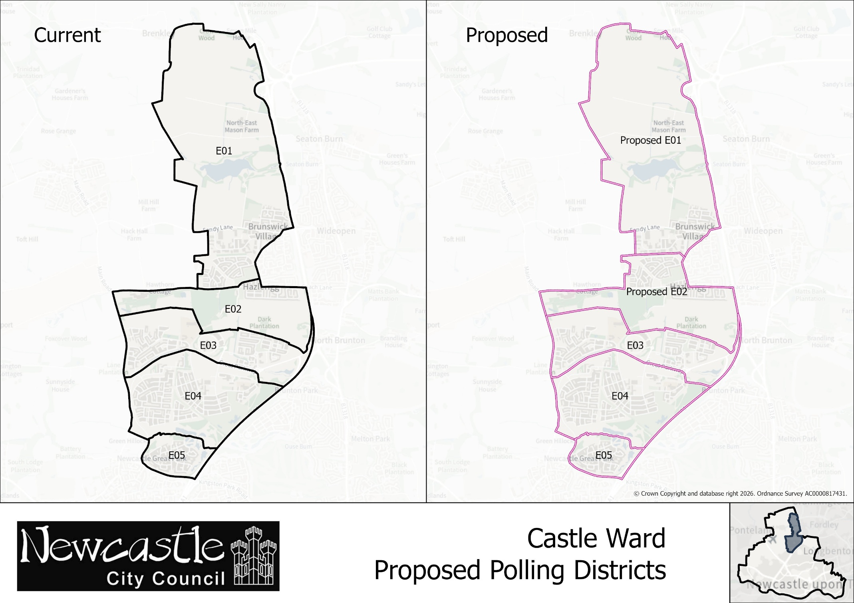
Castle Ward
Polling District E01
Current Polling District | Current Polling Place
E01 | Greenside Rest Centre, Greenside Avenue, NE13 7DY
Proposed Polling District | Predicted Polling Station  Electorate | Proposed Polling Place
E01 | 532 | Greenside Rest Centre, Greenside Avenue, NE13 7DY
Considerations and Proposals
Amend the boundary between E01 and E02 polling districts to align with the proposed parish boundary changes currently being considered through the Community Governance Review. Properties within the Havannah Park development located north of Coach Lane would transfer from E01 to E02 polling district.

No change to the polling place.

Current Polling District | Current Polling Place
E02 | Hazlerigg Community Centre, Hazlerigg, NE13 7AS
Proposed Polling District | Predicted Polling Station  Electorate | Proposed Polling Place
E02 | 1,173 | Hazlerigg Community Centre, Hazlerigg, NE13 7AS
Considerations and Proposals
Amend the boundary between E01 and E02 polling districts to align with the proposed parish boundary changes currently being considered through the Community Governance Review. Properties within the Havannah Park development located north of Coach Lane would transfer from E01 to E02 polling district.

No change to the polling place

Hazlerigg Community Centre is suggested as a double polling station to serve electors in both E02 and U03 polling districts.

Castle Ward
Polling District E02

