Have Your Say on the Forth Yards Draft Masterplan
Farrell Centre Access Guide
Yellow Room, The Sir Terry Farrell Building, Eldon Place, Newcastle upon Tyne, NE1 7RD
Do you need this in an alternative language or format? Please email: ForthYards@newcastle.gov.uk or call
Date: Tuesday 25 November 2025
Time: 6-7.30pm
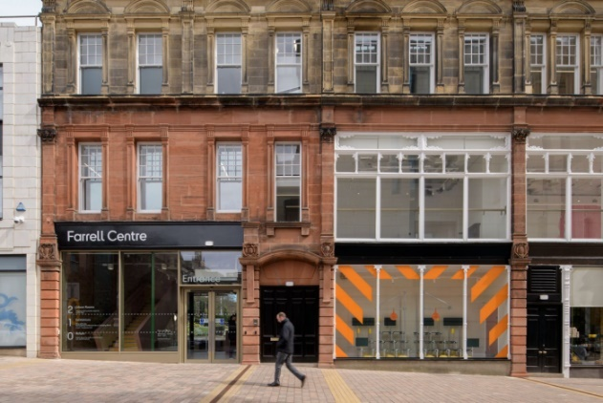
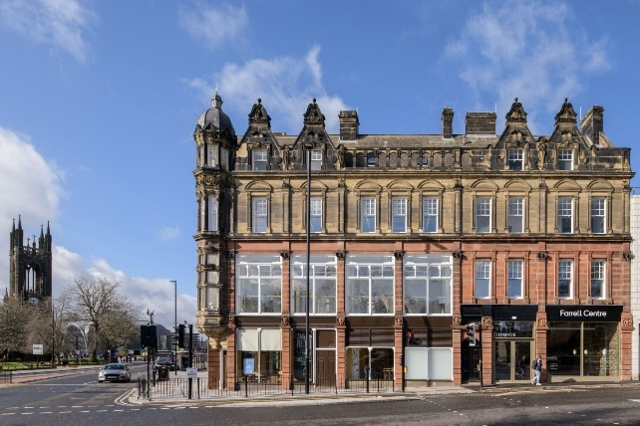
Location: Yellow Room, The Sir Terry Farrell Building, Eldon Place, Newcastle upon Tyne, NE1 7RD
Front of the Farrell Centre on Claremont Road, showing one entrance. | The other entrance to the Farrell Centre, on Eldon Place.

Why is this session happening?
The Forth Yards Draft Masterplan covers 36 hectares (52 acres) of predominantly former industrial sites along the north bank of the Tyne. That is about the size of 50 football pitches. You can find out more about it here: https://www.letstalknewcastle.co.uk/consultations/575/participate
We are interested in hearing everyone’s views on the vision and principles contained in the Forth Yards Draft Masterplan and what people think should be local priorities for the area, to help shape how the area is redeveloped.

What will happen in the session?
Staff from Newcastle City Council will talk about the draft masterplan and what could happen on the site. You can see maps and plans. We will then listen to what people have to say about this.
The information collected will tell us what is good about the masterplan and what could be better, and allow you to tell us what is most important to you.

To learn more about what we are doing, please visit this webpage: https://www.letstalknewcastle.co.uk/events/forth-yards-draft-masterplan-2025-25-november-2025

How do I get to the Farrell Centre?
Follow this link to see the Farrell Centre on Google Maps: https://maps.app.goo.gl/6b7GTtP625XB1Miu6
It is situated in Newcastle city centre.
Parking
The closest public car park is Sandyford Square at Newcastle Civic Centre, which is operated by the City Council. It is about five minutes’ walk from the Farrell Centre. The address is: Sandyford Square, Newcastle upon Tyne, NE1 8PP. The car park has designated blue badge space.
You can find out more about it here: https://www.informationnow.org.uk/organisation/sandyford-square-civic-centre-car-park/
Metro
The closest Metro station is Haymarket, a five minute walk from the Farrell Centre. Both the yellow and green Metro lines run through Haymarket.
Bus
Haymarket Bus Station is a five minute walk from the Farrell Centre, and Eldon Square Bus Station is a ten minute walk. There are also bus stops close to the Farrell Centre on Barras Bridge and St Mary’s Place.
Train
Our closest train station is Newcastle Central Station, approximately a 20 minute walk through Newcastle city centre to the Farrell Centre. Alternatively, Newcastle Central Station is a five minute journey by Metro to the closest metro station, Haymarket.
Cycling
Bike stands are provided on Eldon Place opposite the Farrell Centre’s main entrance. Adult bikes cannot be brought into the Farrell Centre, but children’s bikes and scooters can be left at the Buggy Park on Level 0.

Where in the Farrell Centre is the event going to be held?
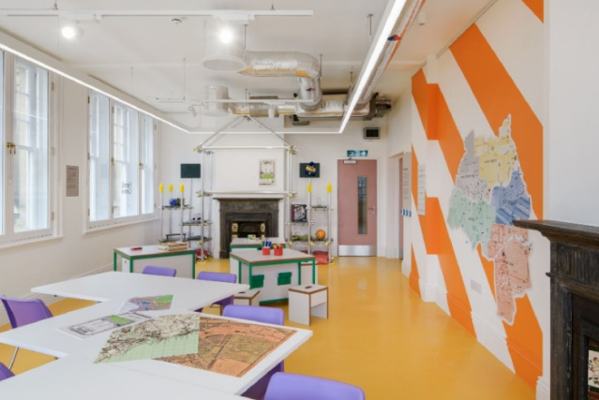
It will be held in the Yellow Room, on the second floor of the Farrell Centre. This is a brightly-lit room with seating available. Toilets are available just outside the entrance to the room. Staff can help you find it. There is a lift and stairs to the top floor. The photograph on the right shows the Yellow Room.

Getting into the building

There is level access into the venue using the front entrance.
There is a reception desk inside the main entrance where you can ask for help finding the event if you need this. The photo shows the reception desk.
The next part of this Access Guide has been taken from the Farrell Centre Accessiblity FAQs: https://www.farrellcentre.org.uk/visit/accessibility/

Is there an accessible toilet?
There are accessible toilets on Level 0 and on Level 2. You can ask staff or look at building signage which will show you the way.

Where are the standard toilets?
Standard female and male toilet facilities are located inside the building.

Are assistance dogs welcome?
Yes, assistance dogs are welcome at the Farrell Centre.

Are there induction loops at the Farrell Centre?
Yes, you can ask staff on the reception desk about using this facility when you arrive.

Are there places to sit inside the Centre?
Yes, seating is available on all floors. On Level 0 this is in the atrium. There is also seating on Level 1 outside the exhibition spaces and on Level 2 throughout the Urban Rooms. If additional seating would help support your visit, you can contact the Farrell Centre in advance, or speak to a member of staff on arrival.

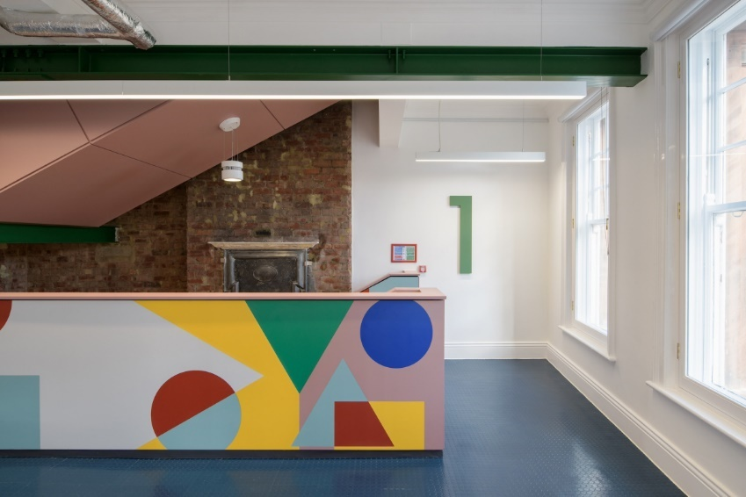
Other information about the building
There is a lift, and all floors are wheelchair accessible.

Lighting levels are bright.

The photograph on the right shows the interior of the Farrell Centre (from the Farrell Centre website).

How can I contact the venue to ask questions about it?
You can get in contact with the Farrell Centre by calling: 0191 208 0071 or emailing: farrellcentre@newcastle.ac.uk

If I have any questions before the event, who can I talk to?
If you have any questions ahead of the event, contact us by email at: ForthYards@newcastle.gov.uk or call: 07817 549 718:.

If I have any questions at the event, who can I talk to?

You can ask Newcastle City Council staff if you have questions. They will be wearing badges showing the Council’s logo (shown on the right). You can also ask staff on the Farrell Centre reception desk for help moving around the building.

Thank you!

Sources for this access guide
This source was used with thanks:
Farrell Centre: https://www.farrellcentre.org.uk/

