Crowne Plaza Hotel Newcastle Access Guide
Planet Suite, Crowne Plaza Hotel, Hawthorn Square, Forth Street, Newcastle upon Tyne, NE1 3SA
Do you need this in an alternative language or format? Please call: 07817 549 718 or email: ForthYards@newcastle.gov.uk
Date: Wednesday 26 November 2025
Time: 3-7pm
Location: Planet Suite, Crowne Plaza Hotel, Hawthorn Square, Forth Street, Newcastle upon Tyne NE1 3SA
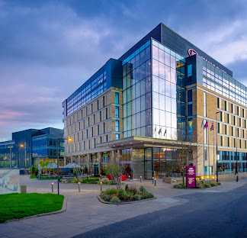
Front of the Crowne Plaza Hotel Newcastle, showing the entrance.

Why is this session happening?
The Forth Yards Draft Masterplan covers 36 hectares (52 acres) of predominantly former industrial sites along the north bank of the Tyne. That is about the size of 50 football pitches. You can find out more about it here: https://www.letstalknewcastle.co.uk/consultations/575/participate
We are interested in hearing everyone’s views on the vision and principles contained in the Forth Yards Draft Masterplan and what people think should be local priorities for the area, to help shape how the area is redeveloped.

What will happen in the session?
Staff from Newcastle City Council will talk about the draft masterplan and what could happen on the site. You can see maps and plans. We will then listen to what people have to say about this.
The information collected will tell us what is good about the masterplan and what could be better, and allow you to tell us what is most important to you.

To learn more about what we are doing, please visit this webpage: https://www.letstalknewcastle.co.uk/events/forth-yards-draft-masterplan-2025-25-november-2025

How do I get to Crowne Plaza Hotel Newcastle?
Follow this link to see the Crowne Plaza Hotel Newcastle on Google Maps: https://maps.app.goo.gl/fDXESEFTg5PktgMV8
It is situated in Newcastle city centre near the railway station. It is not situated on a road which has a steep gradient.

Parking
There is level ground between the car park and the hotel entrance. It has kerb ramps and wheelchair accessible street parking. There is a parking drop-off point next to the main entrance.
Cycling
There are many cycle routes through Newcastle city centre that can be used to cycle to the Crowne Plaza Hotel Newcastle. You can check about secure cycle parking by contacting the hotel directly.
Public Transport
The nearest bus stops are on Neville Street (0.4mile) and Heaton Park Road (0.3mile). They are served by the following buses: 10/10A/10B, X45, 47. There are other bus stops nearby within the city centre.

Getting into the building
There is level access into the building using the front entrance.
The building has level access throughout and ramp access to internal rooms where needed. It is ADA-compliant and rooms are wheelchair accessible.
The building has ADA-compliant lifts within the building giving access to all levels.

Where in the hotel is the event going to be held?
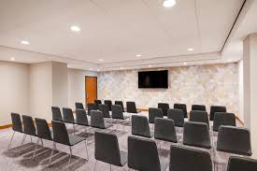
The event will be held in the Planet Suite. Staff at the Crowne Plaza Hotel can show you to this room when you arrive at the hotel. The photograph on the right shows the room (from the Crowne Plaza Hotel website).

Is there an accessible toilet?
There are accessible toilets within the building. They have grab rails and turning space. Tall toilets are available.

Where are the standard toilets?

There are standard female and male toilet facilities within the building.

How can I contact the venue?
If you would like to contact the Crowne Plaza Hotel Newcastle directly, you can do this by calling: 0191 562 3333 or emailing them at: reservations@cpnewcastlehotel.co.uk.

If I have any questions before the event, who can I talk to?
If you have any questions ahead of the event, you can email us at: ForthYards@newcastle.gov.uk or call: 07817 549 718.

If I have any questions at the event, who can I talk to?

You can speak to Newcastle City Council staff at the event. They will be wearing badges with the Council logo on, which is shown on the right.
You can also ask the hotel staff for advice and support in getting around the building, or with any other issues you might have on the day.

Thank you!

Sources for this access guide
This source was used with thanks: https://www.ihg.com/crowneplaza/hotels/gb/en/newcastle-upon-tyne/nclsq/hoteldetail/accessibility

